# Background

The Web Application has been designed for our client Himalayan Food Mantra (YDR Hospitality Group Pvt. Ltd.), which is a big company based on Food Industry introducing various tastes and recipes all around the world.

The food company, Himalayan Food Mantra has been offering a vast range of food services and taste to the customers who are widely looking for an optimum personalized experience with pleasure on each lift of their spoons. Having a diverse nature of customers, the hospitality agency uses its digital platforms in order to reach out to a wider section of the audience, which in turn helps in the growth of the organization through profitability and productivity.

## 2.1. Scope

By providing an optimum user- friendly method of interaction between the company and the customers, the web application is able to ensure a total engagement of the users, and hence a strategic growth of the company. The long- term scope of the web application is designed to provide best level of productivity as well as profitability to the hospitality business company, Himalayan Food Mantra, and ensure its successful tenure. mitigating all the risks and threats associated with the business process, as well as understanding the critical feedbacks and implementing constructive strategies for constant improvement of the company, the web application does wonders in bringing the customer and the company closer. (Neal Hunt, 2016) Defining reliable sources of communication and a wide range user friendly services via online means, the web application serves as an asset to the company's fate making it stand out among the competitors.

## 2.2. Purpose

The purpose of the web application design is to focus towards delivering optimum range of services to the users via online medium. Producing a reliable and an all- round efficient portal for direct communication between the providers and the customers.

With the increase in the market demand for optimum hospitality businesses, this web application has been designed with the purpose of providing sufficient services through a number of practical, convenient and innovative services via online sources. (Kapila Asanga Dias, 2017) Making it easier to conduct orders, bookings, reservations, updates, feedbacks and reviews, the web application has been designed to provide a personalized experience of hospitality to the diverse customers from all around the world.

# Problem of Statement

The need for digitalization of business processes has grown to a very large extent especially after the pandemic. As people all over the world have been avoiding any kinds of physical contact and travel, these online sources of services and products is proved to be a boon in the situation. Providing an interface for communication between the consumers and the businesses in the emerging economy, through digital platforms businesses are making a great shift towards the success.

Web application services enables the organizations and individuals to talk to each other and assimilate each other’s expectations. With the vast range of competitions in the present economy, digital platforms are the key to making the most use of resources and skills and reaching out to a larger section of audience. Through digital platforms such as web applications, businesses are successful at making people aware of the services. Such locations are essential to set the companies qualities apart from the competitors and make it stand out in the diverse market.

As the market has been growing tremendously, limiting the services and products to be available for the customers in manual and paper-based way is insufficient. By relying on the phone calls for queries and third- party software like Uber Eats for receiving the order is very limiting. The client is offered minimum reliable services and has to travel long distances in order to enjoy those services. Marketing of the services and products provided by the company becomes quite a tough job with the lack of digitalized mediums. Moreover, all the data maintained on the paper works does not support the client business to make analysis of the day- to- day business activities.

As a solution to this, a web application acts as an optimum asset to overall efficient functioning of a business process. When the client business wants to go online and host services on the web, the web application comes handy so as their customers can enjoy the benefits and use the facilities provided through the web application. (Paolo Tonella, 2001)

The following project covers about the designing and developing of a web application for hospitality industry, such that the customers are able to order as well as view all the updates about the food. With the help of a web application as such there is no need to rely on third party software like Uber eats in order to provide services to the customers.

## 3.1 Problem Analysis

### 3.1.1 Fish Bone Diagram

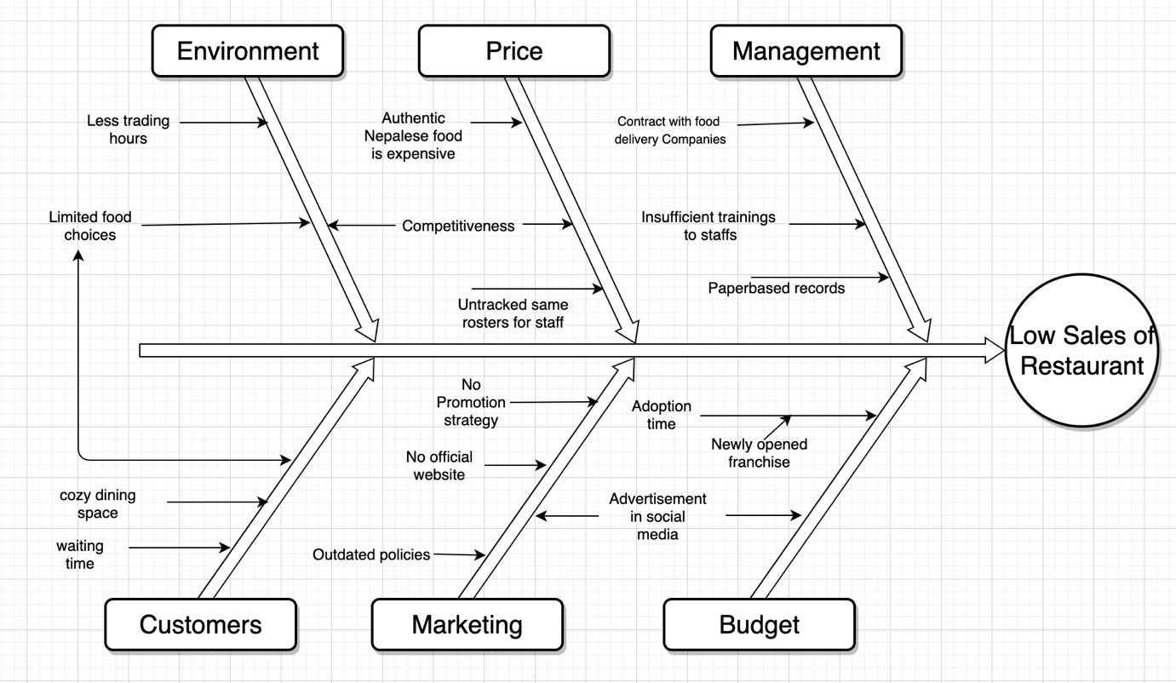

Using Fish bone diagram, aim was to find out the main root problem of the restaurant (low sales) and causes the problem. Here, six causes have been defined for low sales of restaurant which are: management, price, environment, budget, marketing, and customers. To dig into more, the relationship between root problem and causes have been further linked by reasons provided under the causes. For example, spices and elements for preparing authentic Nepalese dish is expensive, however the selling price is low because of the competitiveness. For this restaurant, lack of the website the customer must wait for the order which is pointed in the figure. This is a newly opened franchise, and the budget is limited which is another cause since there is limited allocated money for marketing and going online, which comes under the cause of budget. Similarly, every six causes have been provided with the reasons to match up its relationship with the low sales of the restaurant.

### 3.1.2 Gap Analysis

|  |  |  |  |
| --- | --- | --- | --- |
| Action | Desired Outcome | Current State | Identified gap |
| QR Code Implementation | Scan QR code to view menu page | Completed | 0% |
| Add to Cart | Selected Item should be updated to cart | Completed | 0% |
| Order online | Customer could order from webpage | Completed | 0% |
| Online Payment | Customer could pay online for the order using credit card | Unimplemented | 100% |
| Admin Dashboard | Admin could adjust the details, news, and menu on dashboard | Completed | 0% |
| SMS Notification | Notify customers for the status of food being prepared and ready | Ongoing | 40% |
| Invoice Print | Sending the invoice after order completion | Ongoing | 50% |
| Link up our webpage | Connect webpage to food delivery applications | Ongoing | 30% |
| Contact Admin | Customers can contact admin via webpage | Completed | 0% |
| Manage special deals and items from admin dashboard | Customer can see special deals and items on the webpage and can add to cart. | Completed | 0% |

As per the client, he wanted to have a QR code which leads to menu page while scanned. Our webpage and physically in a restaurant have a QR code, while scanned, leads to the menu page. The main objective of project going online is to order online which will help in sales increment. This feature has been implemented completely which means there is not any gap identified. However, there is about 60% of gap identified to feature paying online via webpage which was requested by our client at the last stage of the product. Due to the time limitation, this feature is still on progress. System pushes SMS notification and invoice to the customer which are identified 40% and 50% respectively. Customers can contact the admin directly via webapp and clear the doubt about the deals or about his/her order. Admin from the admin dashboard should be able to manipulate the information, deals about the food and the news on the website, which can be viewed by the customers directly on Himalayan Food Mantra home page.

### 3.1.3 SWOT Analysis

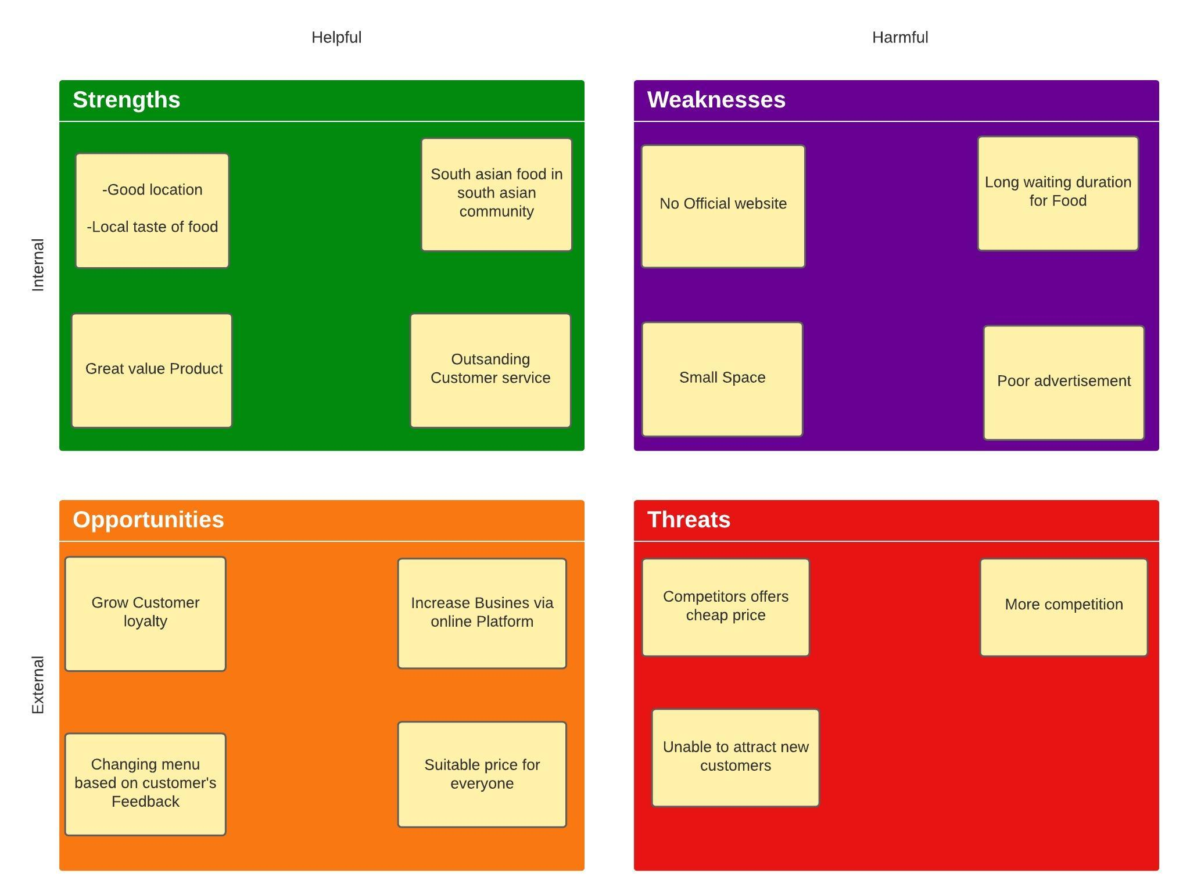

Figure: swot analysis

Based on our Project we did a SWOT Analysis for the restaurant to know the internal strength and weakness of the restaurant and external opportunities and threats of the restaurant. which will help to analyze the business performance and possible chances of growing business and risk in future to achieve the aim of the business. Following is the SWOT Analysis of the ***HIMALAYAN FOOD MANTRA RESTAURANT***:

* **Strength:** Talking about the Strength the restaurant is in a good location, just near to the train station where there is a high flow of people. Besides that, there is a high number of South Asian people living in Campsie, and good customer service is the strong point of the restaurant.
* **Weakness:** one of the major weaknesses of the restaurant is they are paper-based which will take more time for food ordering and delivering. Small space of the restaurant and poor advertisement is another thing which is lacking behind the restaurant.
* **Opportunities:** Providing customer loyalty cards and changing the food menu based on customer review will help to increase the business sales, providing services via an online platform and the suitable price will attract the more customer.
* **Threats:** Nowadays more other south Asian are giving a tough competition offering a cheap food price which is the main threat for the restaurant

# Project Overview

YDR Hospitality Group Pvt. Ltd. is a newly started business founded in 2020. It has been working on the hospitality related business activities including Butchery and Restaurant. The Himalayan Food Mantra which is an authentic Nepalese and Indian Cuisine Restaurant. The restaurant was previously named as AD’s Kitchen located at Campsie, NSW but was soon sold to a new owner.

The company had been looking for a team of software developers so as to develop a website for them to sell the foods and products online. By the use of such a web application, the customers are able to view and make orders of different food items as well as book the AS function hall for various purposes and order a number of catering food items.

## 4.1. Goals and Objectives

The goals and objectives of the web application are well- laid as below:

* To create a user- friendly interface for a hospitality business for visualizing and selling of various food items via online.
* To develop mobile responsive web application.
* To allow role- based activities for the admins and customers.
* To allow the customers to view and place the order for different food items from the given list of catering.
* To allow customers to view menu page by scanning the QR code provided on the table.
* To be able to calculate the price as well as show the status of the order through the web.
* To make the bookings and reservations of the function halls via the online interfaces
* To allow the admin to add and update the products and other items as and when required.
* TO allow admin to visualize the admin dashboard that includes the information’s about ongoing business scenarios.
* To provide an efficient mechanism of promotion for the products, mostly new food items.
* To provide the mechanism for latest news.
* To host the final web application on the server.

## 4.2. Vision of the Project

The demand as well as need for the good hospitality services and products in the market are on a very rapid surge in the present day. A number of hospitality industries, including hotels, restaurants, resorts, and many more are focusing towards reaching out to a larger section of the society and attracting diverse groups of audience. With the vision of delivering their warm presentation of their diverse cuisines right to the people’s doors, the hospitality businesses work towards attracting customers by representing their efforts, a number of ideas and wide range of skills in order to stand out in the competitive market.

However, with an increasing demand of digitalization of services, people are seeking for an extraordinarily reliable and efficient online source of services, so as to visit, order, gain, or view the market products and services and choose from a vast range of options. With the idea of gaining information about hotels, restaurants and to enjoy leisure time with their loved ones, people tend to choose the option that suits to the best of their comfort, and the digital platforms does exactly that.

As hospitality businesses are focused on digital marketing and developing online food ordering web platforms, our team of developers designed a suitable web application serving to the all- round needs of our client business.

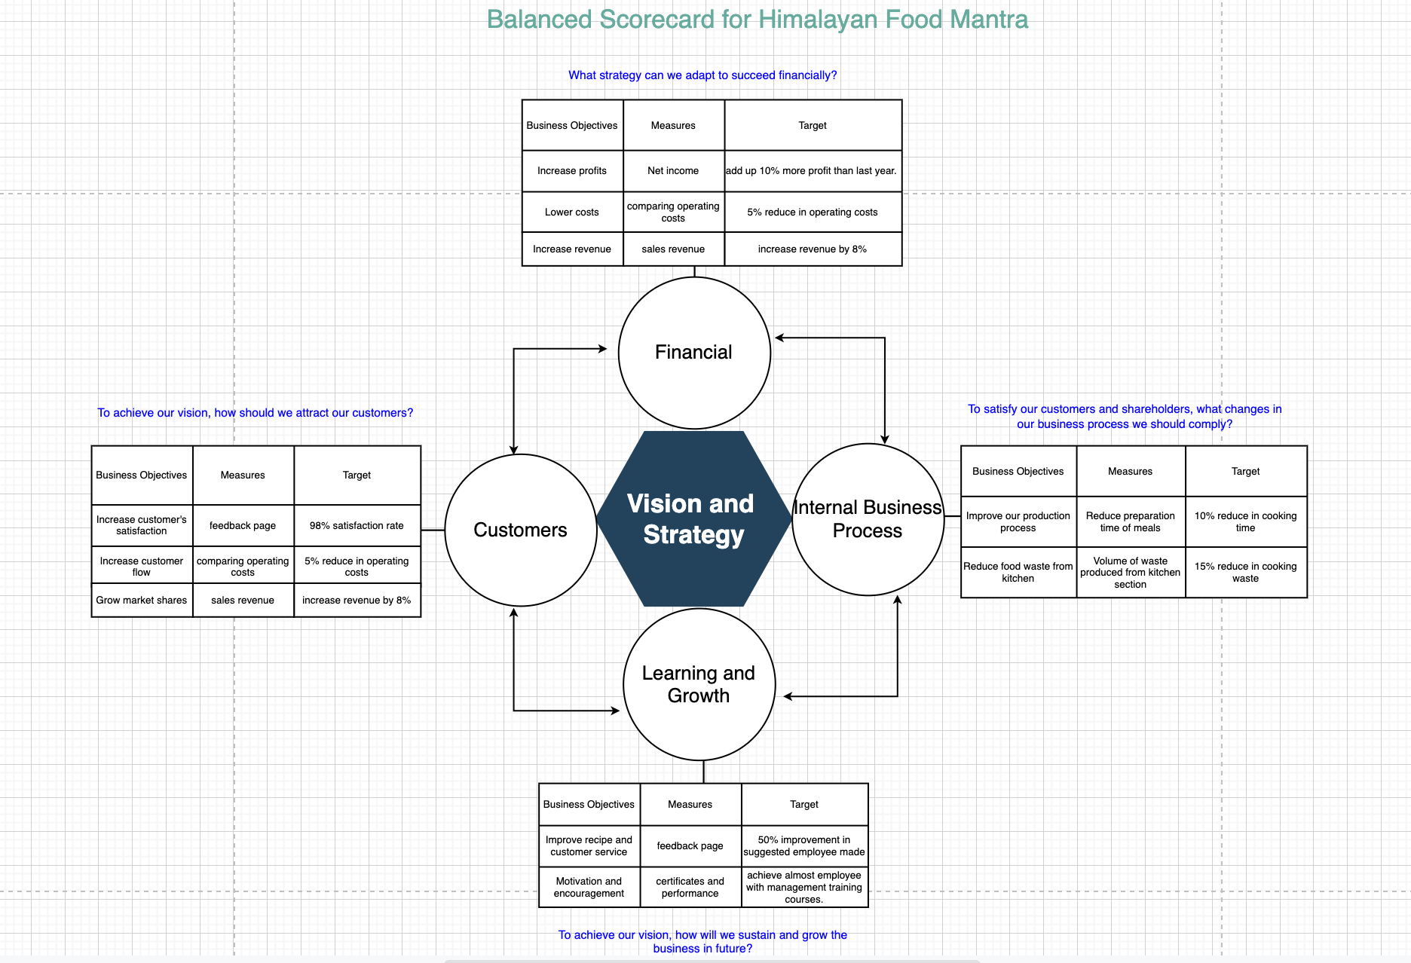*Figure: Balanced Scorecard for Himalayan Food Mantra*

The figure, Balanced Scorecard for Himalayan Food Mantra describes the business’s objectives and the measures that determine whether the targeted goals have been achieved or not. The project has a well- defined set of visions and strategies in terms of the finances, customers, internal processes of business as well as learning and growth.

The financial target of the business process's use of web application is to add up upto 10% more profit to the net income then the last year, reducing the operating costs by about 5%, and increasing the sales revenue by 8%.

The target of the web application in terms of customer service is to secure 98% satisfaction rates among the customers.

The target of the entire in terms of internal business processes is to reduce the preparation time of meals by 10% and also decrease the waste produced from the kitchen section by up to 15%.

In terms of securing the growth and learning of the business process, the target is to secure 50% improvement in the suggested employees and provide certificate and performance courses to the employees.

## 4.3. Success Criteria

The success criteria for the web application development process have been well- defined. The project will be considered successful if:

* The web application shows the products to the customers, and they can place orders.
* The web application is secured for processing the payment for the received orders.
* The web application is as per the requirement of the client and can easily be modified by the client whenever required.
* The project is completed on time.
* Developed web application is mobile responsive.
* The project meets all the functional requirements.
* The project meets all the business requirements.
* The project has been developed within the required scope.

## 4.4. Assumptions

The following assumptions are made as the project plan proceeds:

* The project scope will not be creeped.
* The data that id provided by the client are true and accurate.
* The budget of the project is within the reach of the team members.
* There shall not be any major technological disruption as the project progresses.

# Project Approach

## 5.1. Project Methodology

The approach involved in the designing process of the web application in this project solely depends upon the project requirements. In project, an iterative methodology of project development process in which the design as well as the development of the project can be modified iteratively as and when required.

The agile software development cycle has been implemented in this process which goes through a well- laid structure of the process which includes meeting, planning, designing, testing and evaluating the project approach. (Sheetal Sharma, 2012) The designing and development of this brand- new web application for the client business who are presumed to be having very little knowledge about technology that we have used. Therefore, taking the responsibility of communicating all the aspects of the design and development with the client on a weekly basis as well as asking if there are any modifications or changes, they want to implement in the plan is an essential part of our project approach. We constantly worked on the constructive reviews from the client necessary strategies in order to make the most of our resources and skills and giving out the best results to the client.

*Figure: Agile Software Development Cycle*

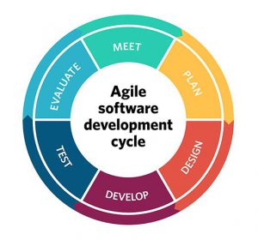The agile methodology which has been implemented in this project plan has been proved to be the suitable one as it allowed us to meet the client regularly and plan according to their requirements. The Agile Software development methodology focuses on the concept of iterative development, in which the requirements as well as the solutions evolve through the cross- functional checking by teams. (Outi Salo, 2002) Using a number of collaboration tools, our team members constantly worked on improving the project deliverable until the clients’ requirements were met. Communicating with the client on how and when the project plan proceeds has been an essential part of our project development process.

## 5.2. Project Dependencies

Project Dependences refers to the logical, preferential or the constrain- based relationship between the activities and tasks so that the initiation or the completion of one take dependent on that of the other. (M., 2016)

In this project, there is a total finish- to- start dependency. This is primarily because the project cannot be started until the meeting with the client is fixed. Also, the design phase of the project cannot be initiated without giving a complete project plan set out, and the development process can only be started after completing the designing process. However, the project methodology in this project is the Agile, implemented in such a way that the start- to- finish dependency of the project may arise during the start of the second iteration of the development process.

## 5.3. Project Constraints

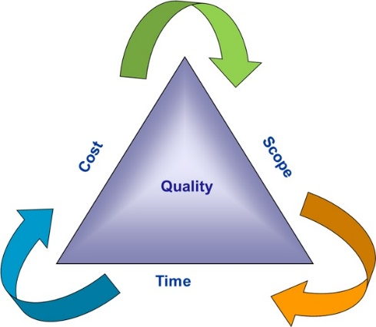 There are a number of constraints that can be encountered during the progress of the project. The triple constraints always arise in any project process, which includes time, cost and the scope of the project.

The figure shows how the overall quality depends upon and can be ensured by the use of efficient costs, scope, and time of the project and avoiding all the related constraints. The goal of the project is to complete the entire designing and development of the web application within the specific range of timeframe, as well as at as low cost as possible along with meeting the qualitative criteria and the scope of the project. This is done by avoiding all the risks, and mitigating all the threats and errors that might exist as loop holes in the plan. (Miller, 2020)

## 5.4. Communication Plan

A communication plan refers to the policy driven approach into providing the stakeholders with all the information on how the project is proceeding and about the future plans. The occasion process involves a formal way of specific information to the stakeholders using a number of channels for delivery. A communication plan includes the stakeholders to whom the information shall be delivered, message aur information that needs to be delivered, communicator who is responsible for the delivery of information, schedule of frequency with which the information is being conveyed, method of channel with which the delivery is done as well as the final comments of the stakeholders. (Nkem Obaji, 2018)

A number of strategies were implemented for an effective communication plan including information about the targeted audience and how the web application can be made as efficient and as effective as possible. The goal of the project is to be able to enhance the profitability and productivity of the business, therefore, working closely with the stakeholders of the business plays an essential part in the success of the project.

## 5.5. Project Schedule

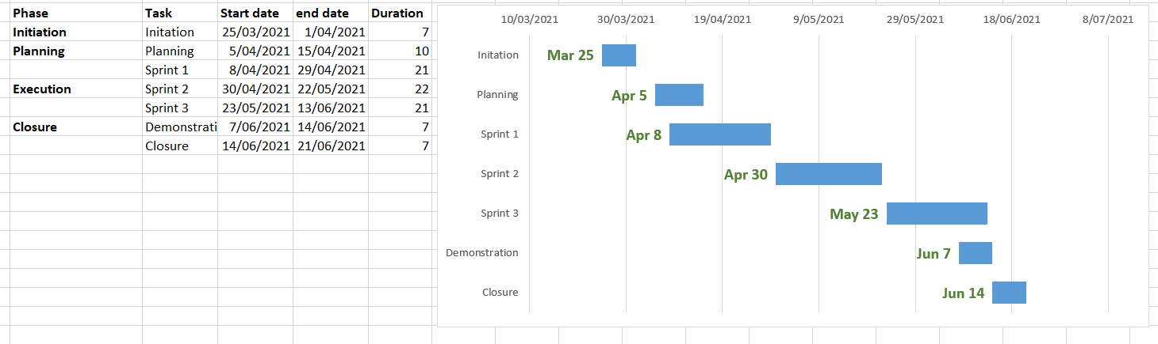The project schedule ensures the smooth process of the project, indicating the process plan, efficient use of resources and laying out the entire project plan within the time frame. The schedule plan described below shows how different phases of the project shall proceed including the initiation, planning, execution as well as closure of the process. (Anon., 2013) All the tasks are well- analyzed and defined in the schedule from the start date to the end date laying out the entire duration.

## 5.6 Data Visualization

Based on the feedback from the survey on google form, we visualize that information as well and showed in different kinds of graphs and diagrams.

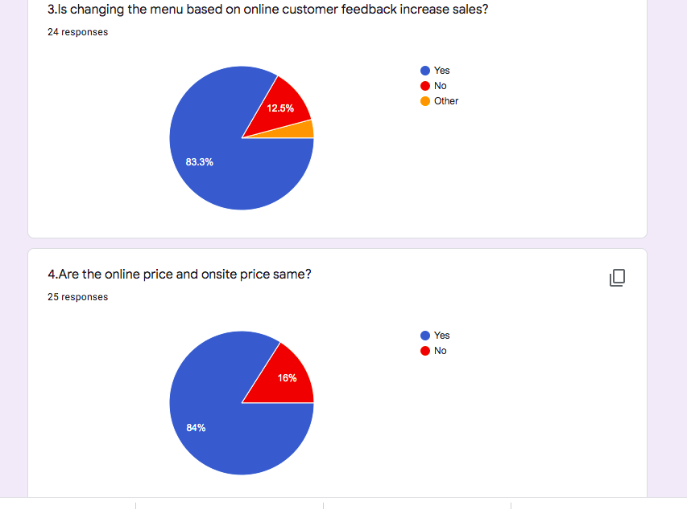

Above is the data and visualization generated based on the questionnaire. Here, we get changing menu based on customer feedback will increase sales and we also know about there is a difference in online and onsite price .

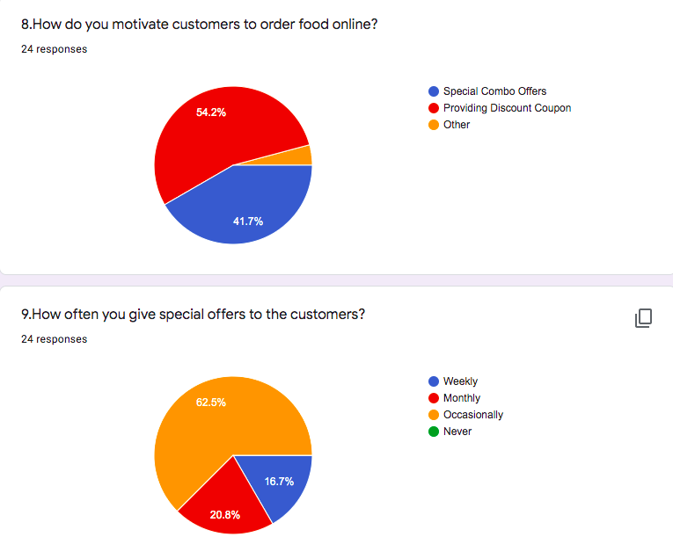

From the above Pie-Chart, we came to know that providing special discount and providing a special offer occasionally will help to attract more customers. Overall, special combo offers of food also help to increase the business sales.

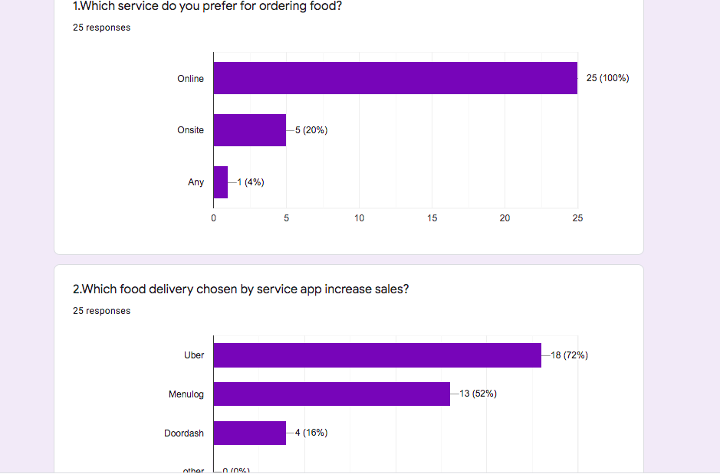

From the above bar graph , it came to know that majority of people want to order food online by using delivery app like Uber followed by Menu log , Door dash and other.

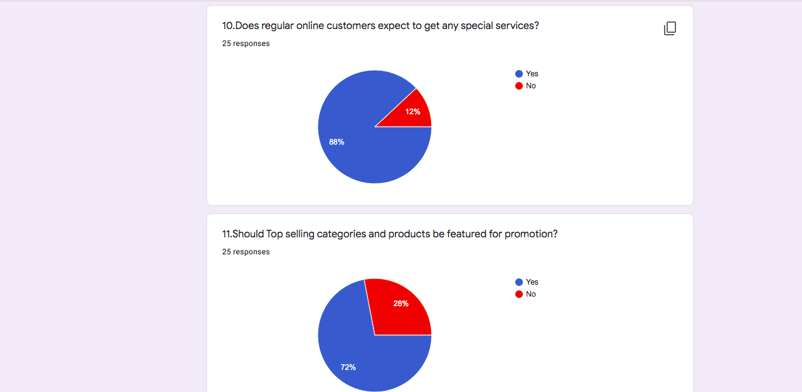

Above Pie Chart explains about the customers expect special services during they order food online and second pie chart expects about top category & selling product should be featured for promotion.

## 5.6.1 Pareto Chart

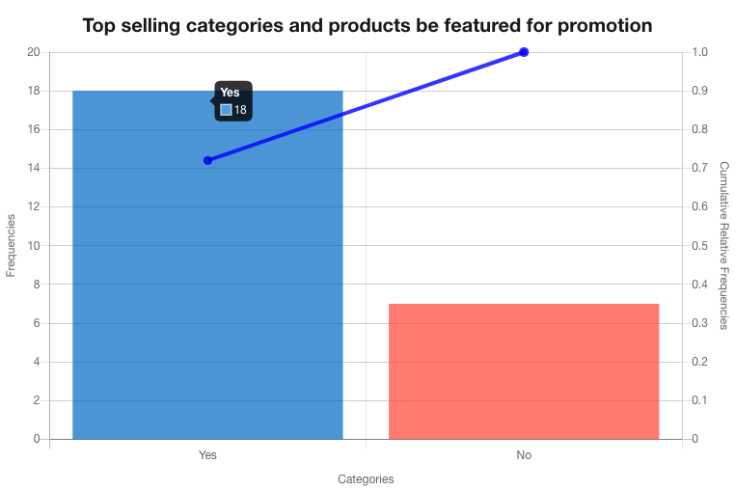

Fig: 1

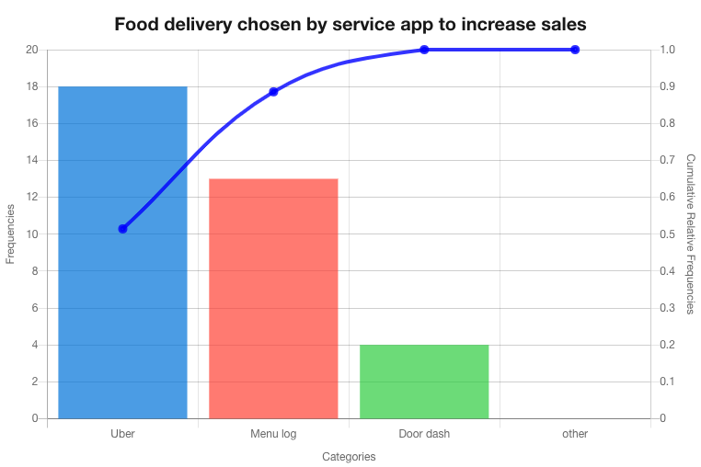

Fig: 2

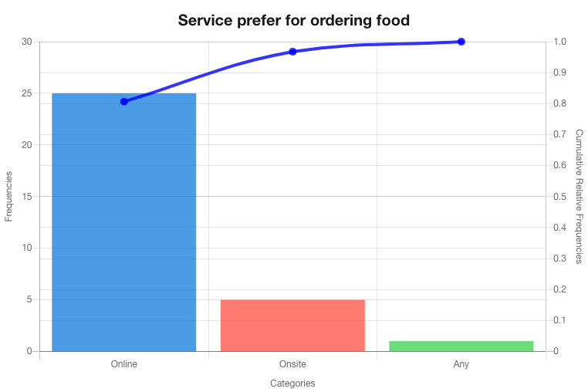

Fig:3

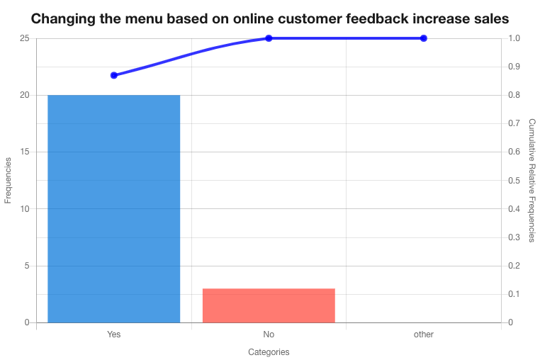

Fig:4

A Pareto Chart is a graph that shows the frequency of faults as well as the cumulative impact of those faults. Pareto charts may be used to identify which faults should be prioritized in order to get the largest overall improvement. Above Figure 1, 2, 3, 4 are the some of the Pareto chart generated based on the questionnaire. There you can a combination of bar and line graph where bar graph is presented from tallest to shortest from there we can know which one is the happen more frequent.

# Requirement Specification

The very first thing that was done while starting with the project is the collection of client’s requirements. Based on these requirements, user stories were created, and user stories were used to create the UML diagrams that specifies the requirements. All user stories were revised, and changes were made whenever required.

## 6.1 User Stories

Below are the user stories that were created based on the client’s requirements. Acceptance criteria for each of the user stories are also provided.

1. As a Customer, I should be able to view all the food items provided by the restaurant along with its recipes.

Acceptance criteria:

* Given that the customer is in home page, s/he should be able to see the menu provided by restaurant.
* When hovered over the food item, customer should be able to see the main ingredient tooltip.

1. As a Customer, I should be able to select one or multiple food items to place order later.

Acceptance criteria:

* Given that the customer is in home page, s/he should view the food items and add to the cart.
* Even after adding the item to cart, customer should be able to see the menu for more order and keep on adding to the cart.

1. As a customer, I should be able to add products to the cart.

Acceptance Criteria

* Given that customer is on menu page, s/he should be able to add the items showed on that page to the cart by clicking add to cart button.

1. As a Customer, I should be able to proceed the checkout of the selected items.

Acceptance criteria:

* After a customer adds the food items into the cart, s/he should be able to proceed with the order by clicking the CHECKOUT button.

1. As a customer, I should be able to make a secure payment for the items being ordered.

Acceptance criteria:

* User should be able to enter his/her card details and payment is proceed through secured payment gateway for the items that has been ordered by customer.

1. As an Admin, I need to receive a push notification of the order placed.

Acceptance criteria:

* Given that the admin at dashboard, s/he should be able to receive the push notification of the order in details placed by customer.

1. As an admin, I should be able to update the status of the order.

Acceptance criteria:

* Given that the admin at dashboard, s/he should be able to change the status of the order as being prepared or ready for pick up or order picked up for the customer and the restaurant staffs.

1. As an admin, I should be able to manage categories as per required.

Acceptance criteria:

* Given that the admin at the dashboard should be able to update the new categories that to be launched, remove the outdated items, and edit the price and details of the food item.

1. As an admin, I should be able to manage products as per required.

Acceptance criteria:

* Given that the admin at the dashboard should be able to update the new products that to be launched, remove the outdated items, and edit the price and details of the food item.

1. As an admin, I should be able to manage new news dynamically for website.

Acceptance Criteria:

* Given that the admin is on the admin panel, s/he should be able to add new news to the web application, delete outdated news and edit any news whenever required.

1. As an admin, I should be able to promote any items I want on the home page.

Acceptance criteria:

* Given that the admin at the dashboard, s/he should be able to update the special food of the day (with special price), which can be viewed by the customer.
* Admin should be able to show the special deals for the customers with terms and conditions.

1. As a customer, I should be able to view the latest news relating to the restaurant.

Acceptance criteria:

* Every customer should be able to view the latest news that has been updated at the button of home page by an admin.

1. As a customer, I should be able to scan QR code that leads to the website with the menu of the restaurants.

Acceptance criteria:

* After scanning the provided QR code at the table, customer should be able see to the main menu of restaurant on the website that pops up, where they can view the details of the food items.

1. As an Admin, I should be able to visualize the dashboard.

Acceptance Criteria

* Once the admin login to the system, s/he should be able to visualize the dashboard.

1. As a user, I should be able to use the web application on any mobile devices without losing any features.

Acceptance Criteria

* The web application should be mobile responsive.

## 6.2 UML Diagrams

UML diagrams are used as basis to analyze, design, and implement the web application. Different diagrams that were created to dive into the requirements of the web app implementation are provided below along with its explanation.

*Figure: Use Case Diagram of Himalayan Food Mantra*

The use case diagrams help to illustrate the behavior of the system together with various players that are involved in managing, maintaining, and executing of the web application. These help up in understanding the roles played by various system actors against the system. The pictorial representation provides scope of the system together with the higher- level functions that are performed by the application (Waykar, 2015).

As per the use case diagram given a verb there are two major players of the system. First one is the administrator of the system. After the administrator has successfully logged in into the system by providing appropriate credentials, the admin is logged in into its dashboard. The administrator can update the status of record as per the process. Administrator is also facilitated with authentication to perform crud operation against a system regarding categories of various products as well as a various product items that are available currently at the restaurant. Not only this to keep the user interact with the system on a regular basis, but the user is also facilitated to update various latest news that are interesting and can keep the users engaged with the system. Finally, t administrator is allowed to manage various elements of his or her own dashboard (Radoslaw Klimek, 2010).

Now, regarding the functionalities that is accessible to the customer. Initially in order for a customer to enter into the system, he must register himself by signing up with the application form of the website. After all the necessary document has been made in the customer is now authenticated to get into the system. The system has various categories and products available that to be added by the admin (Miloudi, 2018). Customer can explore the details regarding the availability of service and can add the decide service to the system cart. Customer can henceforth purchase the product by following the checkout procedures and making the payment. The customer has accessibility to contact the administrator directly. Also, the customer can give the valuable feedback to the system to make for the improvement in the future. Customer can explore various latest news were updated by the admin to know about the ongoing.

### 6.2.2 Data Flow Diagram

Together with analyzing the system layout and designs for the application, it is necessary to understand the data flow that goes on within the system. Information goes through various processes within the application. It includes input data into the storage, the sub processes that helps in processing of the data attained and then finally generating the outcome as per the necessity. For this, standardized notation and symbols are defined to construct the data flow diagram that describes various entities of the system together with their respective attributes and the relationship between those.

Regarding the data flow diagram, the admin can fit in the login credentials into the system. Also details regarding items and categories information are managed in the database. Together with it the status of the order and acceptance of the order is also managed by the admin. Admin can update news regarding various latest events of the restaurant in the application for the customers to view. The web application can send the admin push notifications when the order request is successfully completed. Customers can register and then login into the system by feeding in the necessary credentials. The database has information regarding customer and payment for the order request. The information flows from customer’s side to the web application. The next entity is restaurant. Information about restaurant menu is stored in the database and is fed into the application. The

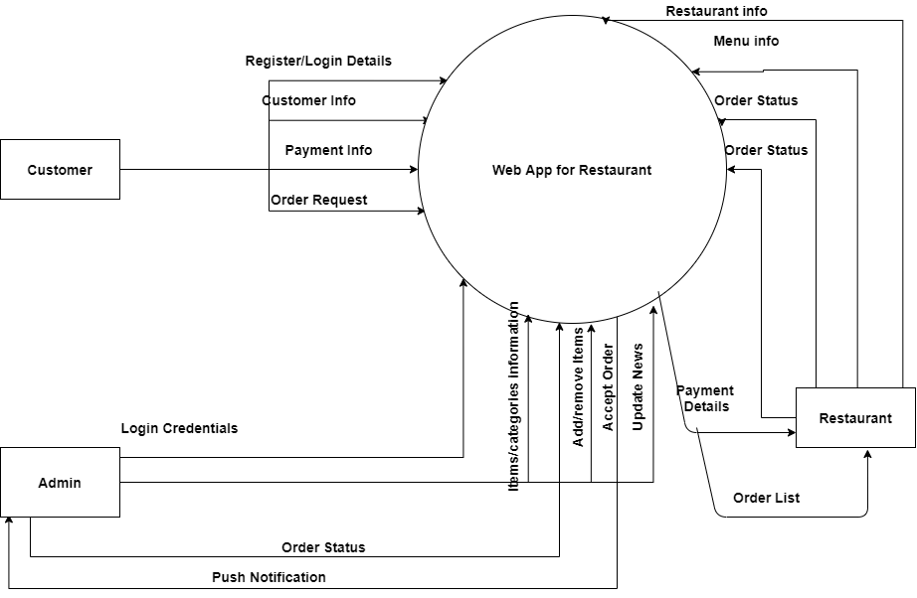

*Figure: Context Level Diagram of Himalayan Food Mantra*

flow of data regarding status of order is sent into the application. Also, the payment details are received from application and the list of orders received from the customers is also transmitted to the restaurant. In this way the overall data flows within the application among entities like customer, admin and restaurant with the application (Bangerter, n.d.).

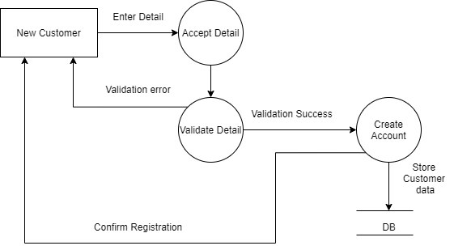

Figure: DFD for Customer Registration

For a new customer, they must be registered to the system so that they can login to the system later. To register as new customer, they need to enter their detail on registration form if the details are validated, account will be created and the registration related data will be stored in the database and confirmation of registration will be shown to the customer.

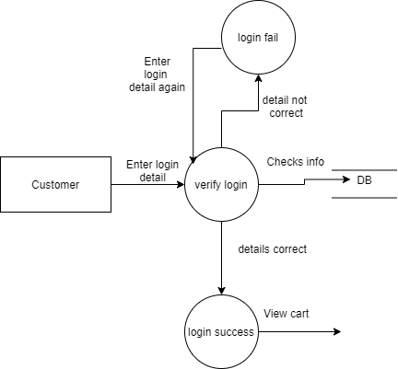

Figure: DFD for Customer login

A registered customer should be able to login to the system using the login credential. Once the login details are provided, verification of those details will be done by the system by matching the details with that stored in database. If the details are correct, customer shall be logged into the system and if not, they will be prompted to login page again to enter the login detail again.

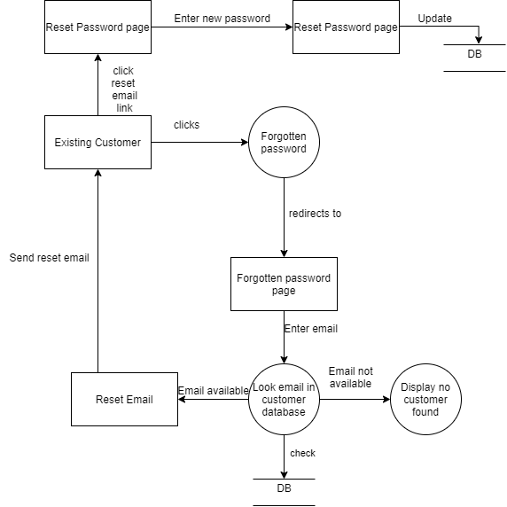

Figure: DFD for resetting password of customers

In case customers forgot their password, they should be able to reset their password. DFD above shows how the data will be flowed in the system while resetting the password. Existing customers will first click on the reset password button that redirects them to the forgot password page. They will then enter their email address associated with the account and the system will look for that email in the database. If the email address is found on the database, the system will send the reset email to the customer’s email other wise the record not found message will be displayed. After receiving the reset email, they can click the link provided in the email to set their new password. While doing so, new password will be updated to the database as well in the system.

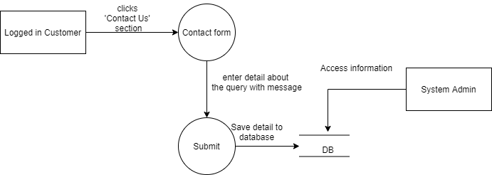

Figure: DFD for Customer contacting the admin of the system

Any customer can contact the admin of the application. For that, they will first click on ‘Contact Us’ section that shows up the contact form. Then customers can enter their detail about the query with their message and when they click on submit button, those details and messages will be saved to database and admin can access those details anytime from the database.

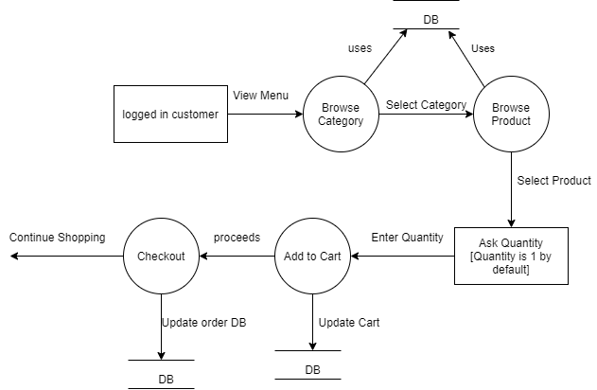

Figure: DFD for add to cart functionality

A logged in customer can add any item to the cart. While doing so, they can browse category and products that utilizes the database to show category and product. Customers can select the item they want to add to cart and can enter the quantity of product as well. When they click on ‘Add to Cart’, selected items will be added to the cart database and checkout can be proceeded.

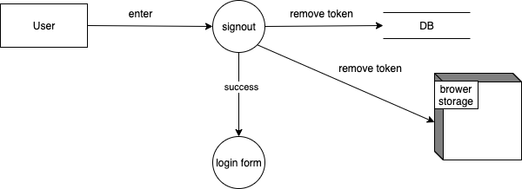

Figure: DFD for customer sign out

Users can sign out from the system by clicking the sign out button. While doing so, token of that user will be removed from the database and the browser storage and the login form will be shown again.

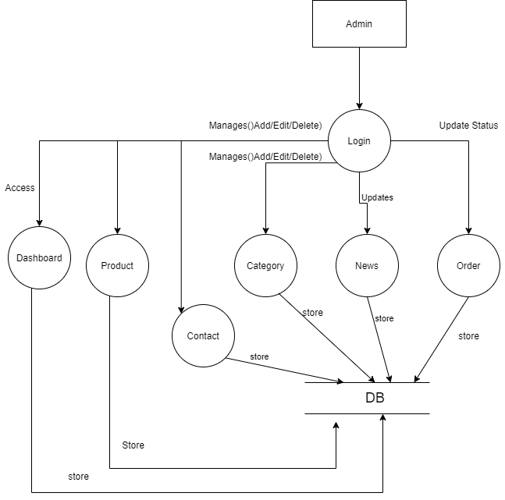

Figure: DFD for Admin Login

Admin of the system can login to the system and can perform different kinds of task. Once the admin is logged into the system, they can access the dashboard, manage products, category, contact, news, and order. All the related data while managing different sections will be updated to the relevant database.

### 6.2.3 Entity Relationship Diagram

In any application, data base plays an important role as it is the major source for storing and retrieval of data related to the application. The database helps in sorting filtering and searching of the available information based on the request of website from user side. Database can also contain various codes that can perform mathematical as well as statistical calculations of the stored data that helps in supporting the outcomes generated via the queries. With the help of a better database design, web application can save a lot of space in the storage at the server by reducing of redundant data.

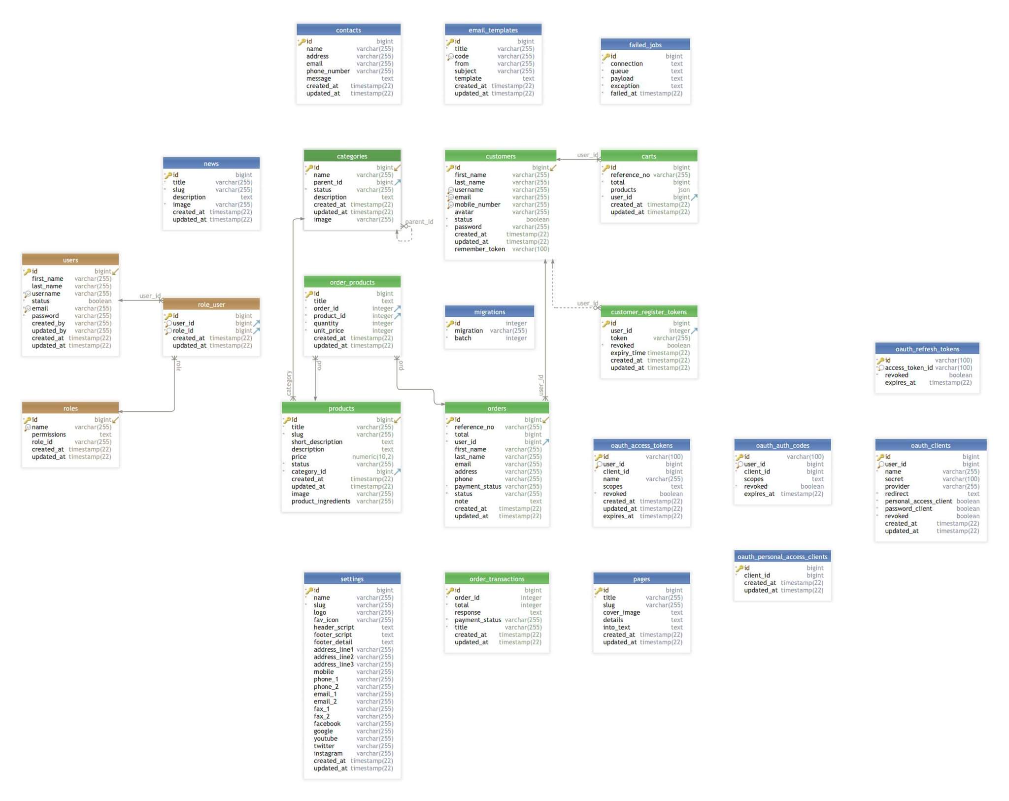

*Figure: ER Diagram of Himalayan Food Mantra*

The above-mentioned ER diagram includes various entities and their respective attributes that helps to know about how the database of the web application has been designed. In the diagram, various entities such as user, admin, customer, category, product, payment, news and more. These entities have their attributes as per the requirement of the website. Each of them has a unique ID, which helps in other entities to access them. With the help of these entities data related to website is stored and maintained and is also retrieved by the request made via the end users of the application. These entities can have one to one, one to many or many-to-one relationships. It is important to design the database and the attributes efficiently. This also helps maintain data precisions and reliability, as it facilitates accessing of data in various ways. Moreover, with database that is well designed, it is easier to maintain as well as use the data stored in the database (Naeem, 2021).

### 6.2.4 Sequence Diagram

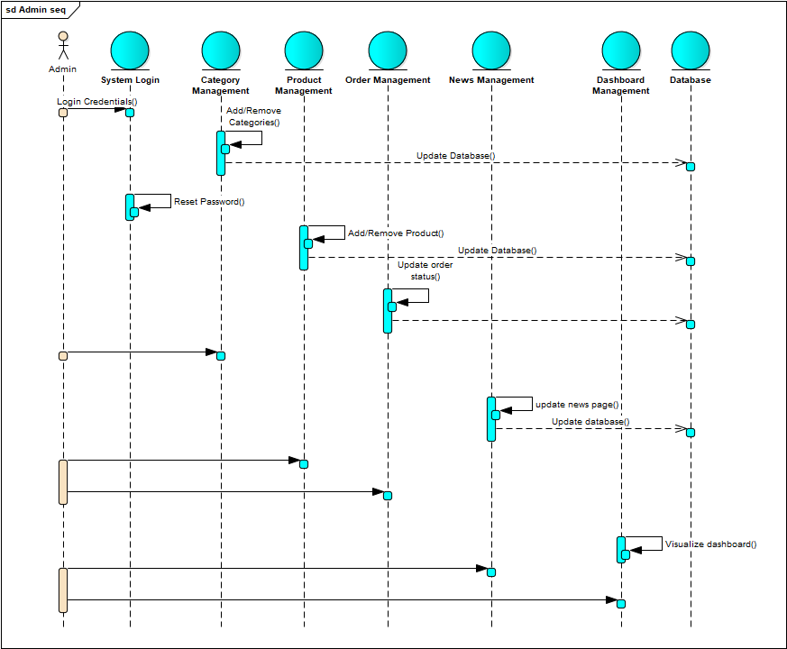The behavior of the system can be explained with the help of sequence diagram. The diagram describes how various objects and group of objects interact together with each other. This diagram can prove to be one of the most efficient for these software developers as well as the business professionals to view and analyses the details regarding the system being constructed and the overall behavior of the application. It helps in representation of the details of the UML diagram such as use case. It also helps to diagrammatically represent the sophisticated functions and procedures of the system. (Abdulrahman Ahmed Bobakr Baqais, 2018)

.

*Figure: Sequence Diagram of Himalayan Food Mantra*

The above diagram mentions various objects of the system that interact together to provide the final outcome as required by the application. From the perspective of admin, the admin can login into the system by providing appropriate credentials. After the credentials have been verified the admin can login to the dashboard of the application. There are different management operations done by the admin such as category, product, news and many more such management. As per the data uploaded by the admin in the system regarding category and products available, it is available on the website for the user to view and explore. When any customer places an order via the website by making payment the push notification is delivered to the administration page to start processing regarding the same. The admin is facilitated to manage his or her own dashboard as per the need. It helps in understanding regarding how objects and its various components interact with one another to successfully attain the objective of the process. It also helps to understand and plan regarding the existing scenario of this system together with planning of advanced features in the future. These various features help the administrator to manage functionalities and content of the website (Oksana Nikiforova, 2014).

### 6.2.5 Activity Diagram

Logical viewpoint presents the logical component that has been used in order to carry out functionalities in the application. It includes the major activity that the application carries out (William W. Cato, 2020).

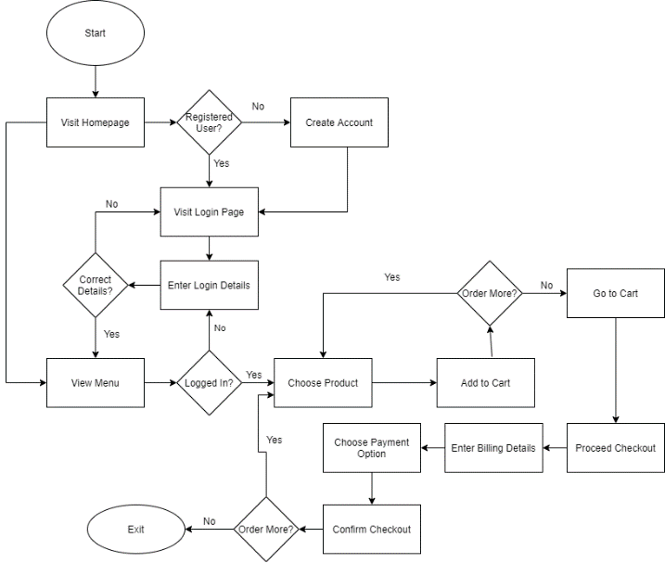

*Figure: Flowchart of Himalayan Food Mantra for Customer*

The diagram includes a series of steps that are incorporated together to carry out functionalities of the application. Initially the customer searches for the website using the URL address of the site. As soon as the user enters the website home page is displayed. It includes various buttons that directs user to respective menu pages. The customer can also directly jump into the menu page by scanning the QR code given on the table. As per the liking the customer can add the item to the cart. User can then proceed to the checkout processing and make secure payment using the gateway. After the payment has been successfully done detail about the order as well as payment is transferred to the administrator. The order is then accepted, and the status is updated. This is how the overall major activity of the web application is carried out (Little, n.d.).

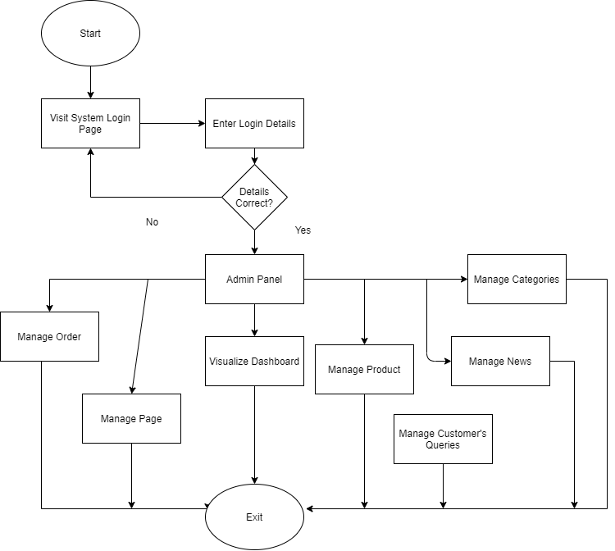

Figure: Flowchart of Web Application for Administrator

The flowchart for administrator describes the flow of task for the system administrator of the web application. They could be able to login to the system admin panel and perform different major tasks of managing the web application’s content like managing pages, news, products, categories and can visualize the dashboard that shows the ongoing business activity through different charts and diagrams. Administrator of the system are also responsible for handing the received orders and managing all the customer’s queries and messages.

## 6.2.6 Class Diagram

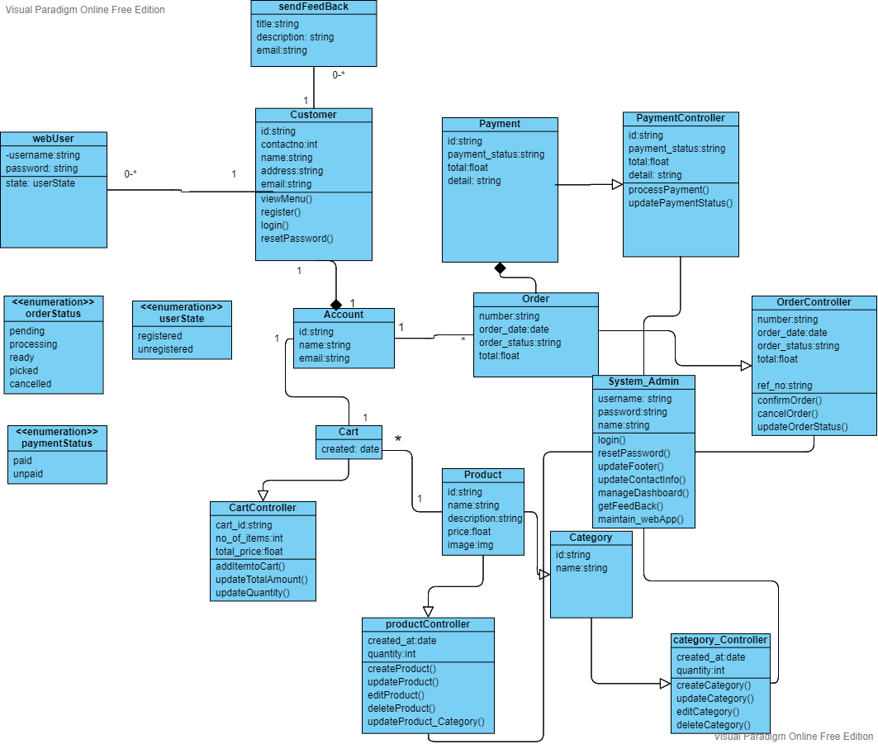

Figure: Generic Class Diagram for Web Application

The Diagram above is the class diagram that shows the major entities of the web application. It also shows the attributes of all the entities along with the operations associated with it. The relationship among the entities is also provided. There exists one to one relationship between customer and account as one customer can have only one account. Also, there is 1-to-1 relationship between account and cart as one account can have one cart allocated to it. There is one to many relationships between account and order as one account can make one or many orders; one to many relationships between cart and product as one or more products can be added to the cart. Different enumerations like orderStatus, paymentStatus, userState are also provided that gives the status of order, payment, and user respectively.

# Design

Figure: Wireframe for Frontend of Web Application

This figure illustrates the optimum utilization of tools and techniques in designing wireframe. This design resembles the pictorial approach of flows in the project. The application used to design those wireframes are Photoshop and Sketch app. However, the links on the pictures are generated by using sketch app that has a function to create the artboard and linking it with points with the next appropriate artboard.

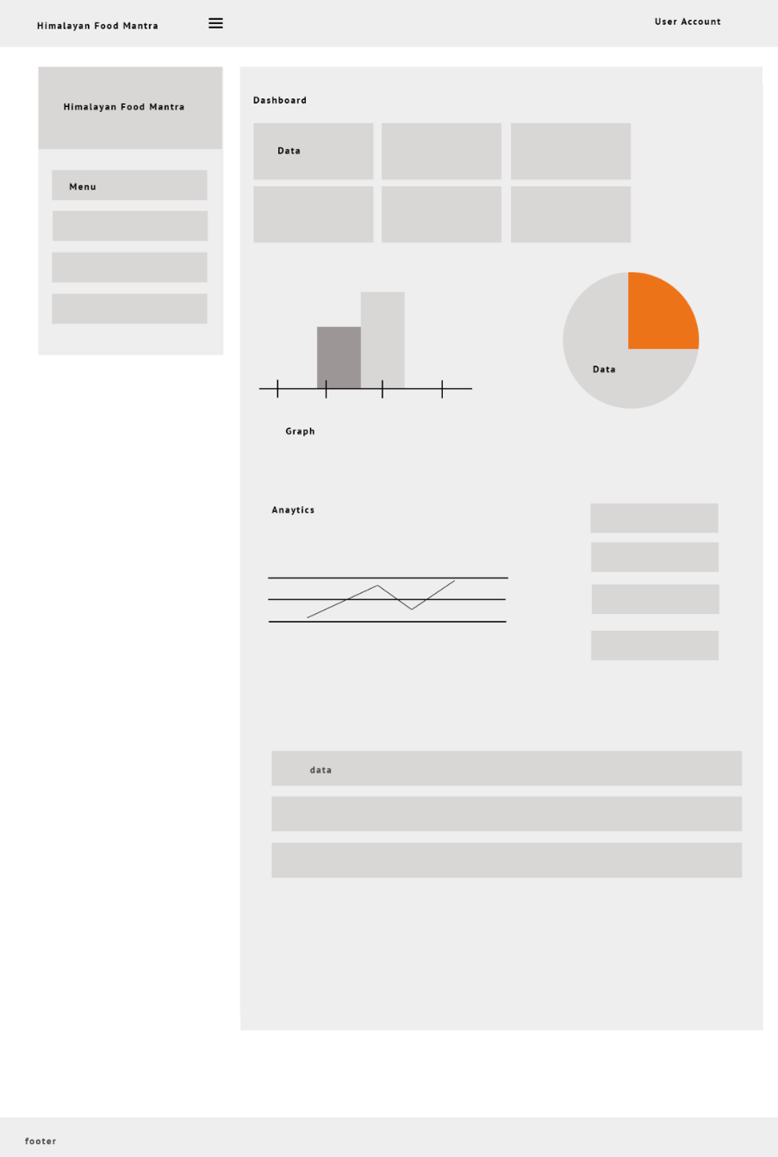

Figure: Wireframe for Backend of Web Application

This wireframe describes the clear concept of how content management system of the product becomes which we also called backend. The wireframe denotes what can client change and visualize through the system.

## 7.2 Dashboard Design

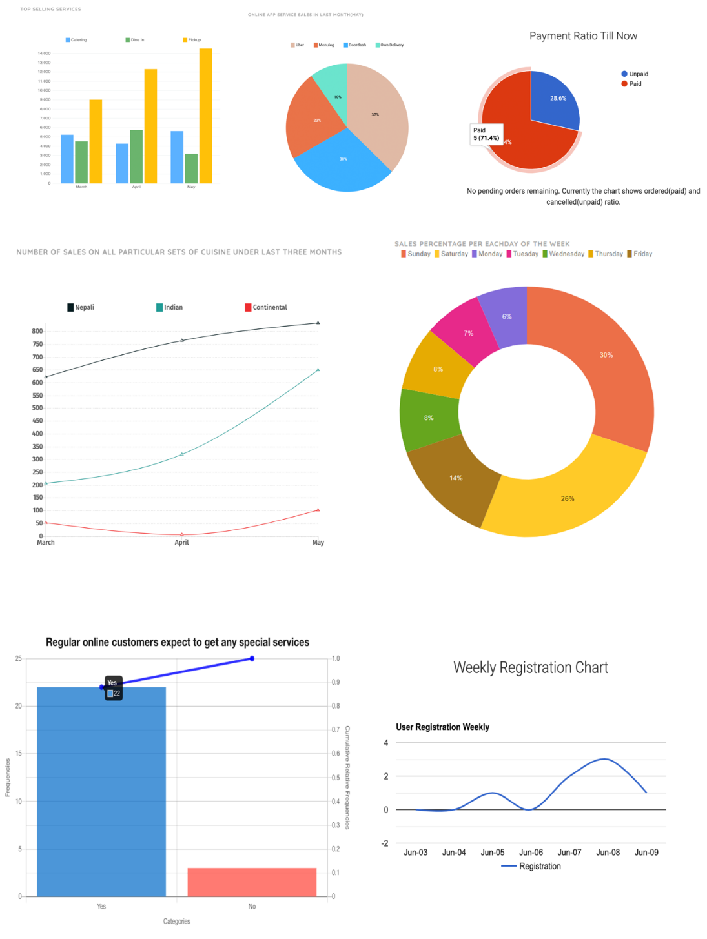

Figure: Dashboard Design

This figure represents the analytical dashboard design of business sales appropriate to the last three months of business operation of Himalayan food mantra. Power BI is used to generate the diagrams with given dataset provided by client.

# Implementation

## 8.1 Tools and Technologies Used

There are several tools and techniques that are used in construction of the web application. Building of frontend designs and layout completely varies from the backend ideas and logics. Database queries and storing and retrieval of the data as per the demand requires various logical implementations. For the development of Himalayan Food Mantra, the following tools and techniques were used (Mowforth, 2020).

|  |  |
| --- | --- |
| **Analysis and Design Phase** |  |
| * UML tools | draw.io, Enterprise Architect |
| * Database Design tool | DB visualizer |
| **Project Methodology** |  |
| * Methodology used | Agile methodology |
| * Project planning | Scrum |
| **Designing Phase** |  |
| * UI tools | Adobe Photoshop |
| * UX tools | Adobe XD |
| **Development Phase** |  |
| * Programming language | PHP Laravel. |
| * Front end Language | HTML, CSS, JavaScript, Bootstrap |
| * IDE | Visual Studio Code |
| * Database | MySQL |
| * Version Control Tool | Github |

## 8.2 System Architecture

As we used Laravel framework of PHP as programming language while implementing the web application, it provides the implementation of Model-View-Controller (MVC) architecture. In MVC architecture, Model represents the class for each of the tables that were created in the database, and it interacts with View and Controller to perform different operations within the system. View is the User Interface that users can view through the browser. Controller is responsible to get the input from the users and can interact with views and model to process the user’s input.

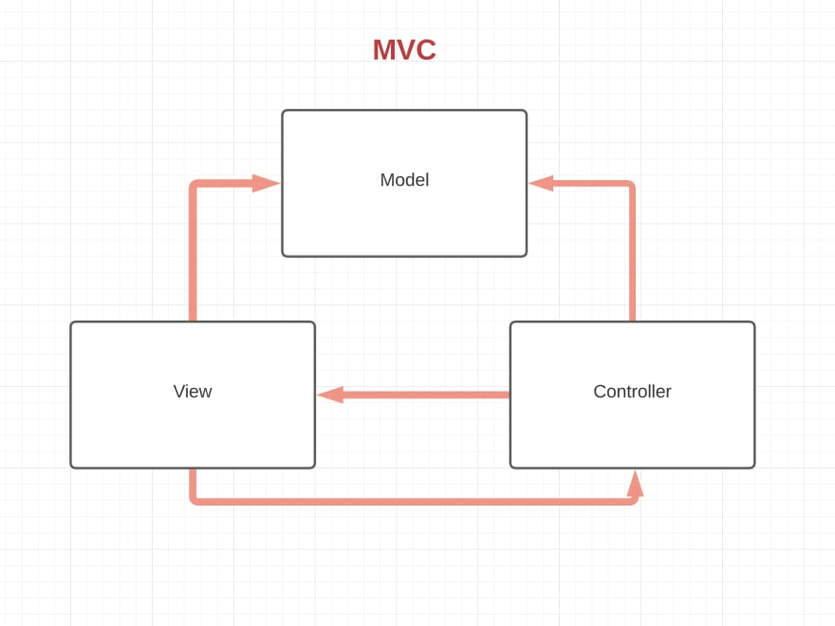

Figure: MVC architecture

## 8.3 Implementation Process

The implementation of the web application is broken into three steps.

* Frontend Implementation
* Backend Implementation
* Integration of Frontend and Backend

To implement the frontend of the web application, which is the part of web application that customers can view and interact with, we used bootstrap framework which is the CSS framework that is the mixture of HTML, CSS and JavaScript.

Backend Implementation is that part of the web application, which administrator can interact with. PHP Laravel has been used while working with the backend of the web application. Once the backend is implemented, both the frontend and backend of the web application were integrated together. To integrate frontend to backend, all the html files of front end were converted to blade file as required by the Laravel framework.

The main process in implementation of web application is the integration of front end and backend of the system. Migration files were first created that would allow us to create the database. Those migration files contained all the SQL commands that will be used to create our database as per ER diagram. Once the migration files were created, we ran the migration that successfully created the database as per required.

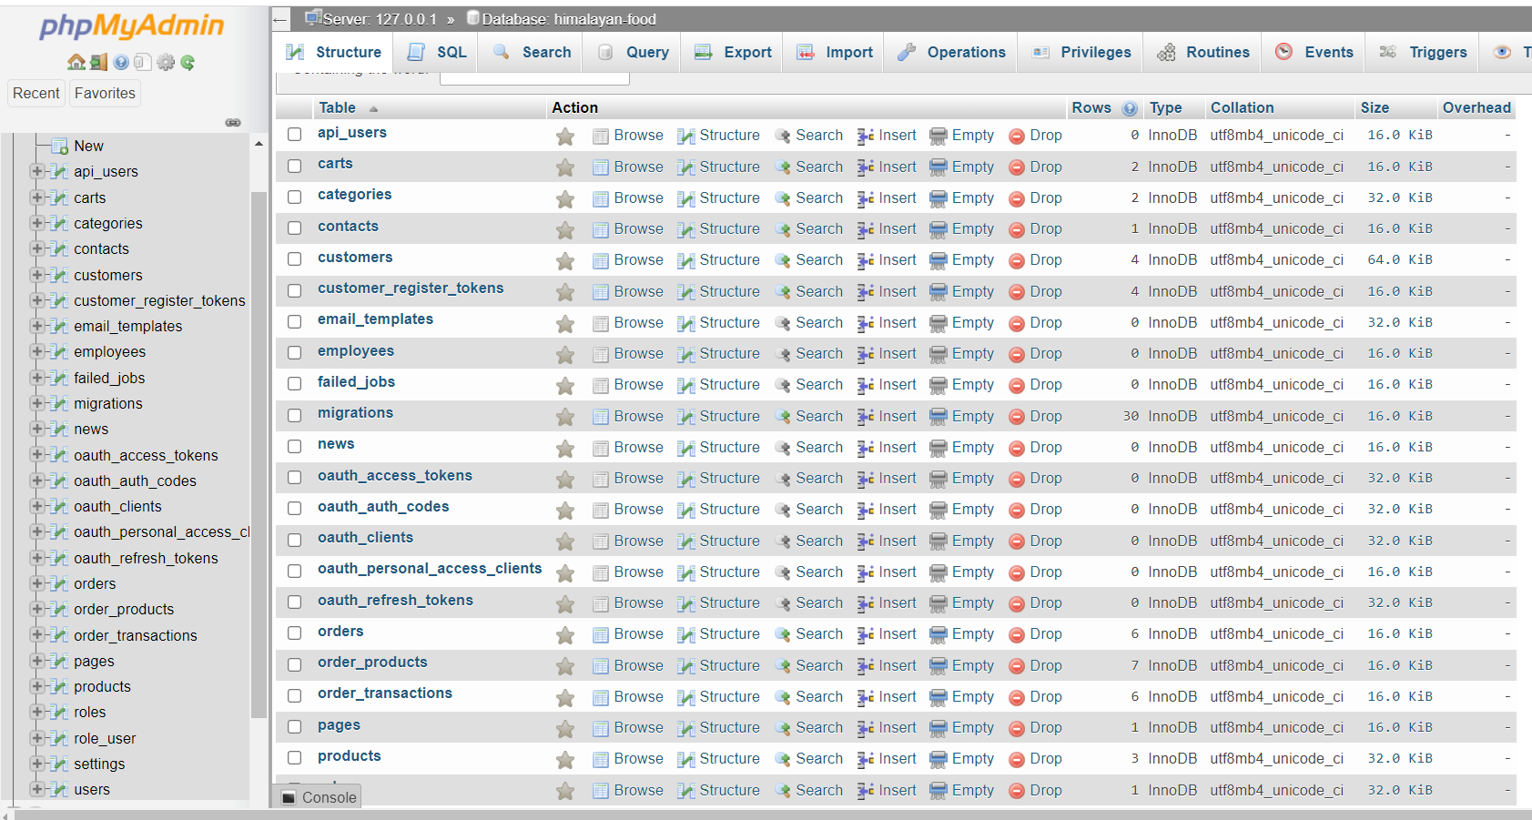

Figure: Implemented Database for the web application after running Migration

After database implementation, Controller for each of the user request were implemented. Those controllers will receive user input and perform required operations by interacting with the database (model) and returning the required View in browser to the users. Once the controllers were created for the web application, Routes were created that would specify the specific view to be returned by each of the controller.

Code segments have been provided in the appendix.

# Discussion of the product

## 9.1. System Overview

The web application "Himalayan Food Mantra" is this system build focusing on providing the users with optimum facility to view various food services available in the restaurant. The application majorly focuses on introducing the tests and recipes to people all around the world. But what's new with this web application. The system also gives information about the food recipes that helps in enhancing and maintaining transparency and flexibility to the potential customers. The system also supports in carrying out the day- to- day activities of the hotel and restaurants regarding receiving the orders processing and maximizing the customer satisfaction. The web application includes various features such as online menu that can be viewed by the customer at any time any place, together with it, the system supports the online ordering feature. It helps to track the delivery routes to enhance the. This feature increases the flexibility and transparency among the service provider and the service receiver.

As mentioned in the document they are majorly two players of the system. One is being the admin and another being customer. Initially for an individual to access into the system, the customer must register their account by filling up the registration form. After all the information has been fitted to the system, the user can now login into the account. The user can also view various available services of the hotels and restaurants as per their liking. Also, they can easily check out truth system by adding their desired item to the cart. We can make payment via secure payment gateway. They can directly contact the administrator as well if they have any further queries regarding the service. Together with it, they can also give their valuable feedback to the system.

Now for another major player of the system the administrator can login into the system and update status of various orders that have been placed into the system. As the customer reviews various products as per their category, these categories and products can be added, deleted, edited by the administrator. In order for the customer to interact with the system, the admin can also update news regarding the service or restaurant. The administrator has been facilitated with feature to manage their dashboard. We can also promote any product as per the strategic plan made by the restaurant. The administrator is authenticated to manage information of company, customers and rest of the users of the system. They can also view the status of the record such as pending, processing, ready for pickup, picked up and cancelled orders. In this way, the overall system works hand in hand to support restaurant services by integrating maximum customer satisfaction and introducing latest features to them. (SINGH, 2020).

## 9.2 Interface Viewpoint

These include several layouts and designs that are displayed to the end users of the application. The interface of Himalayan food Mantra is well defined and constructed keeping user easiness in mind. The more user friendly and interactive outlook the system has, the more uses it can attract. The end users are able to extract maximum benefits out of the web application, it can lead to overall success of the system. To explain further the screenshot of the web application has been presented as follows.

#### 9.2.1 Frontend Layout

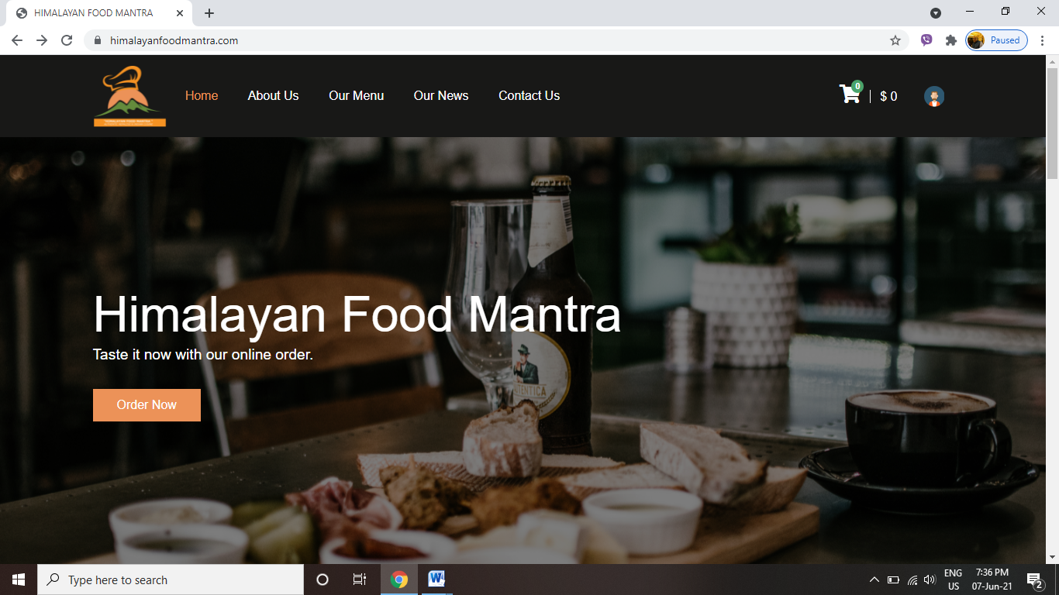

*Screenshot: Homepage of Himalayan Food Mantra*

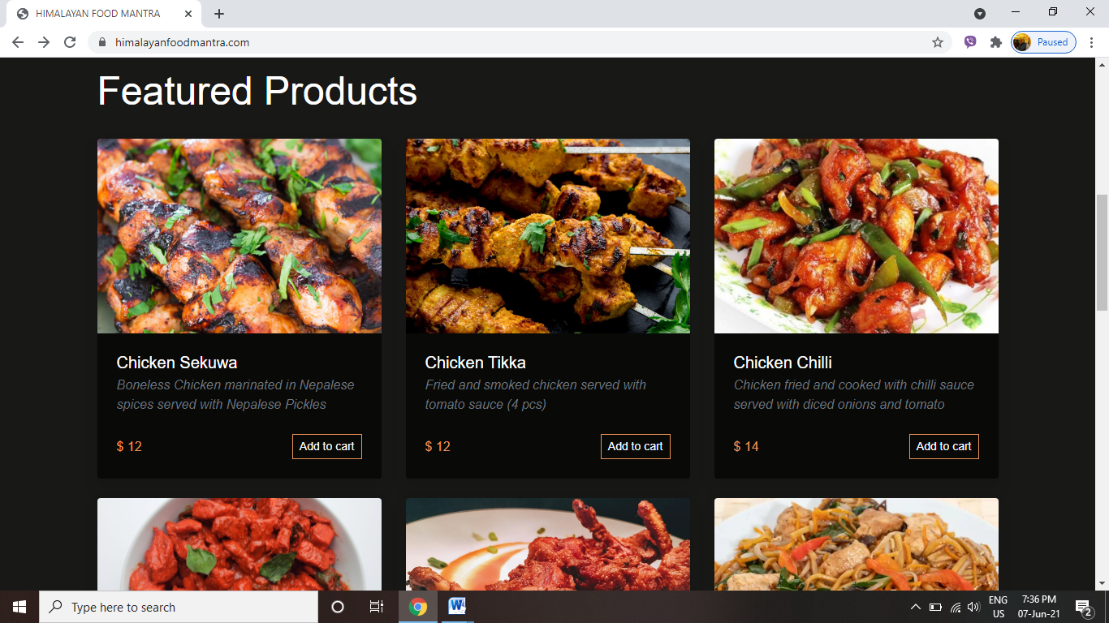

*Screenshot: Featured Product of Himalayan Food Mantra*

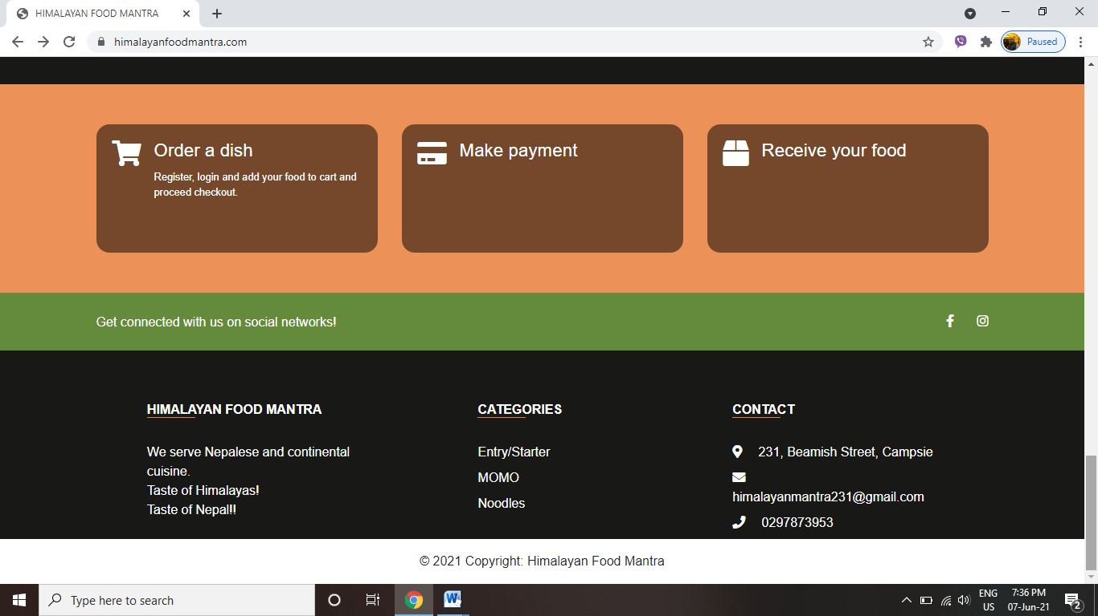

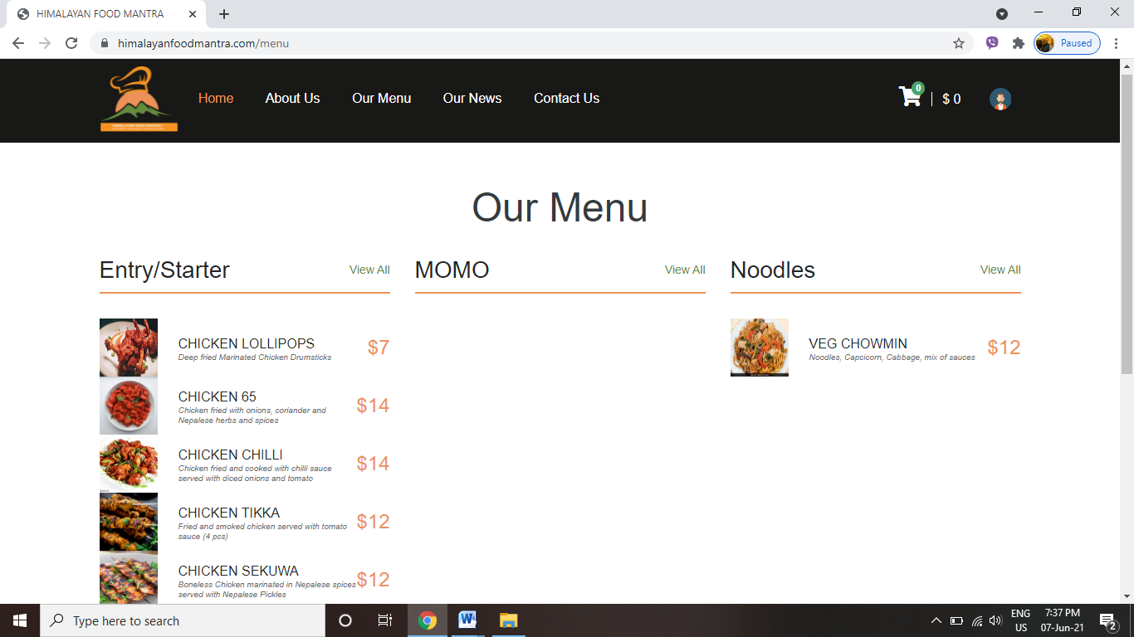*Screenshot: Features of Himalayan Food Mantra*

*Screenshot: Menu of Himalayan Food Mantra*

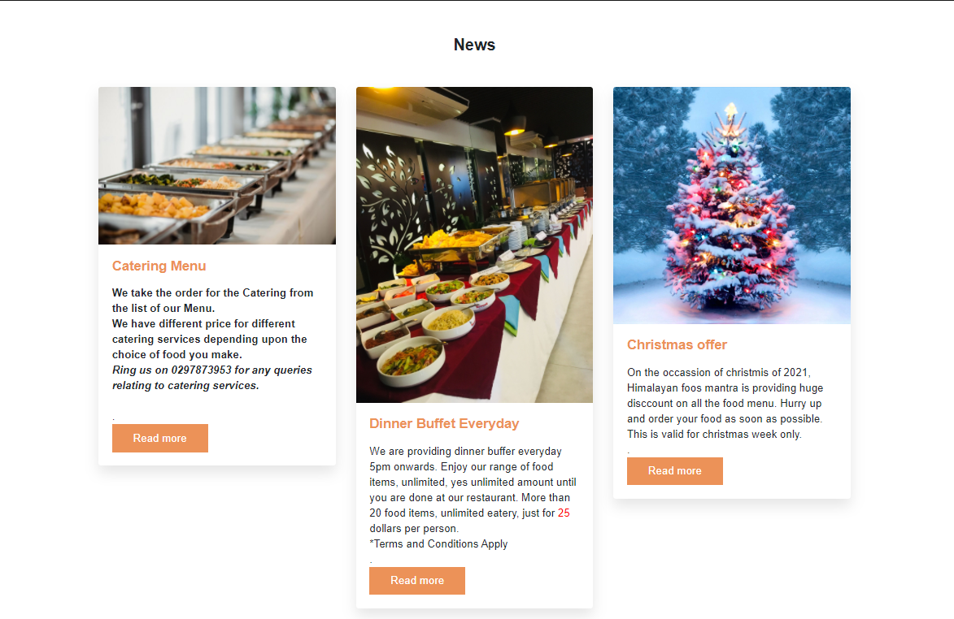

*Screenshot: News of Himalayan Food Mantra*

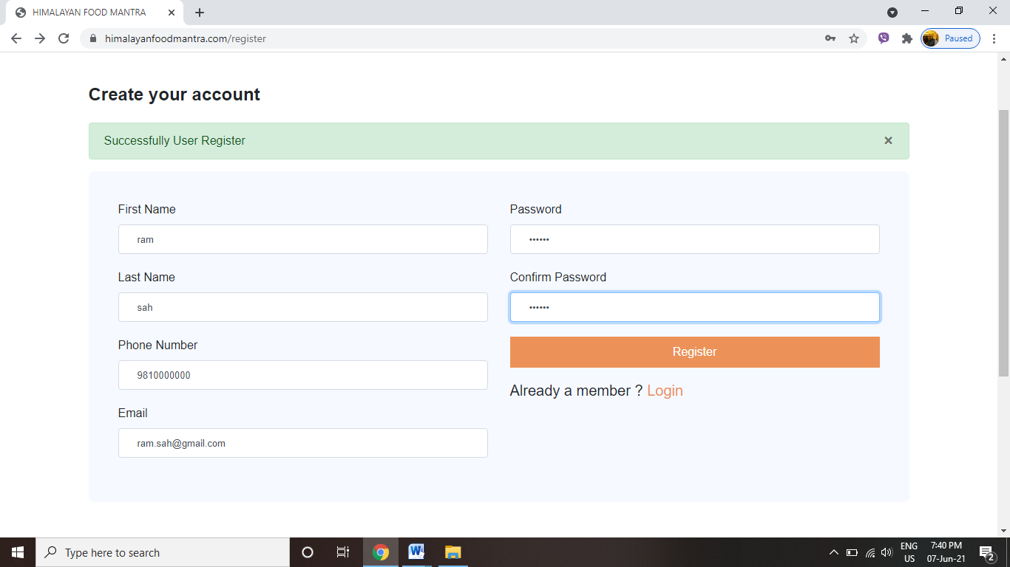

*Screenshot: Contact us form of Himalayan Food Mantra*

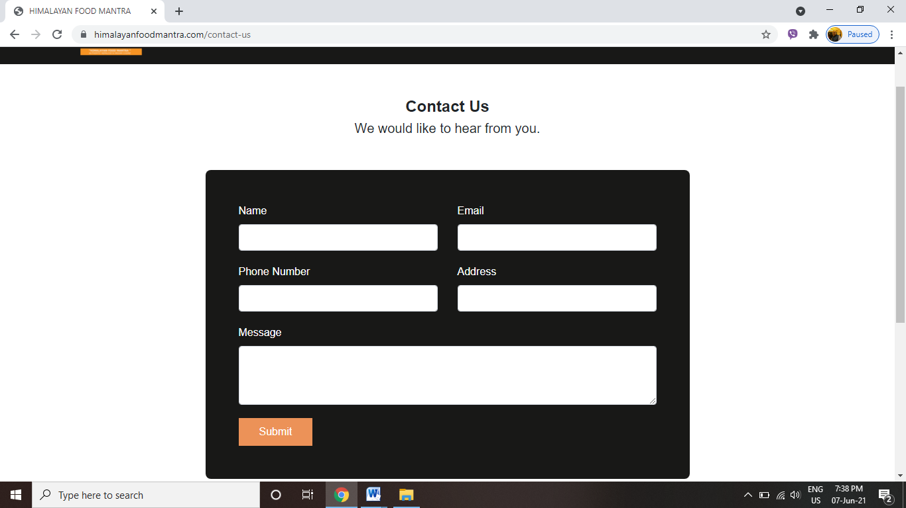

*Screenshot: Register form of Himalayan Food Mantra*

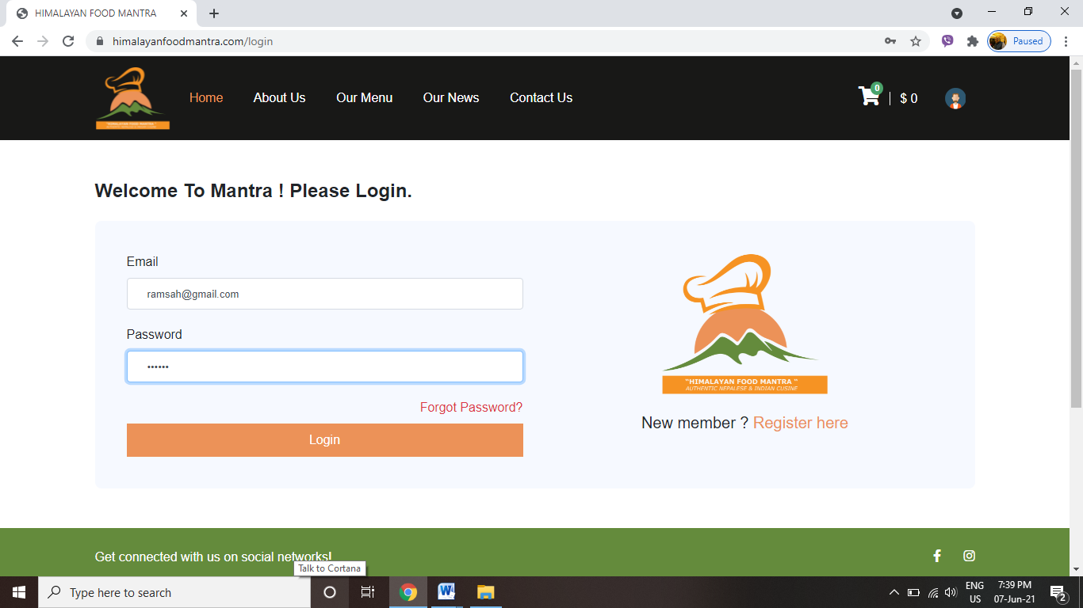

*shot: Login form of Himalayan Food Mantra*

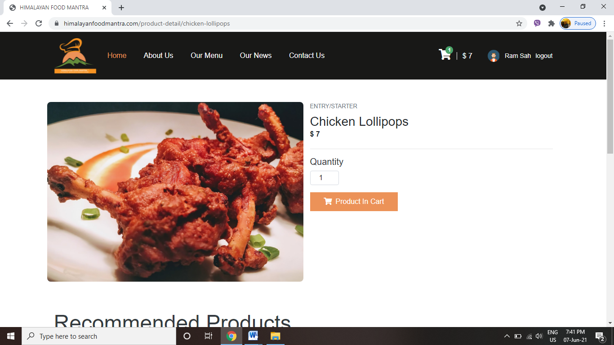

*Screenshot: Details about Product of Himalayan Food Mantra*

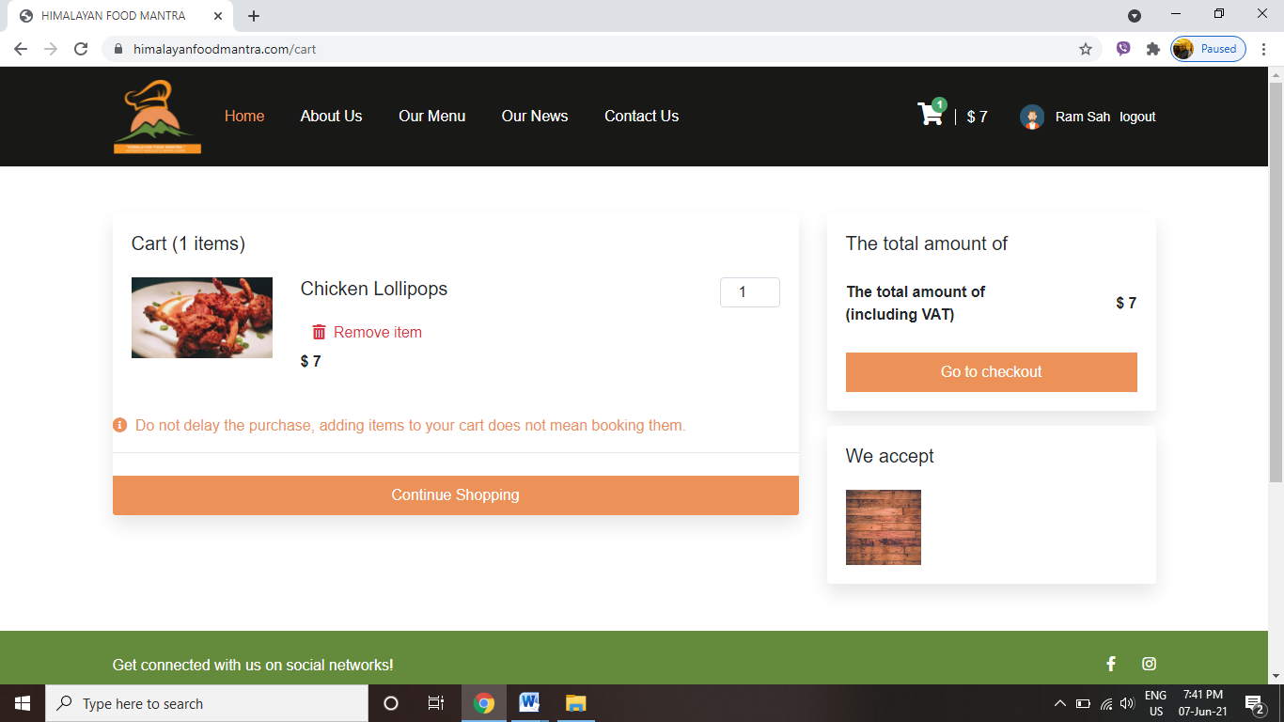

*Screenshot: Cart of Himalayan Food Mantra*

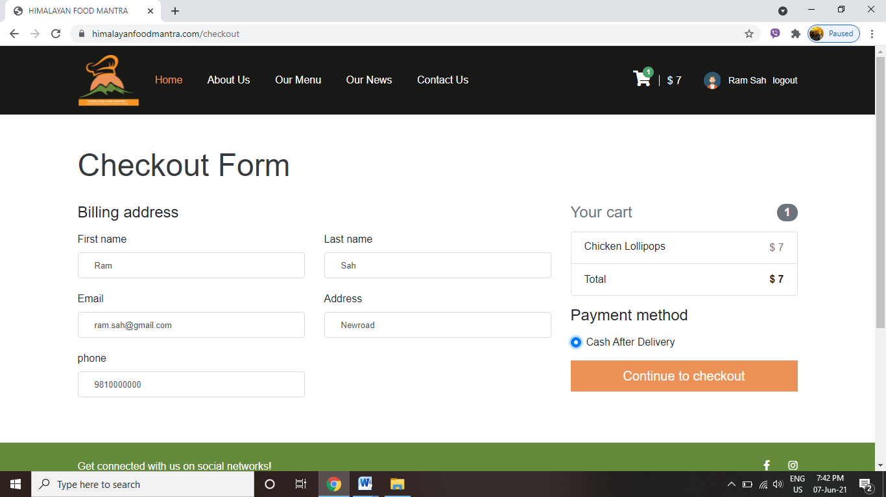

*Screenshot: Checkout form of Himalayan Food Mantra*

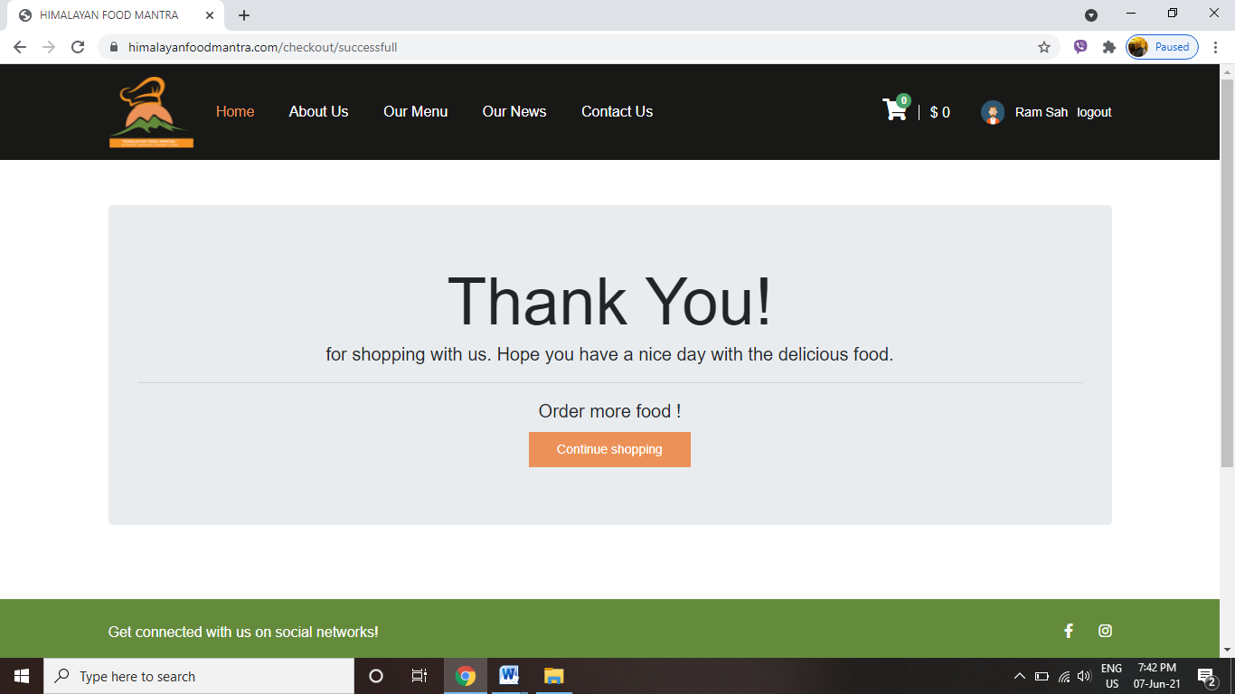

*Screenshot: Successful checkout of Himalayan Food Mantra*

#### **9.2.2 Backend Layout (System Admin Panel)**

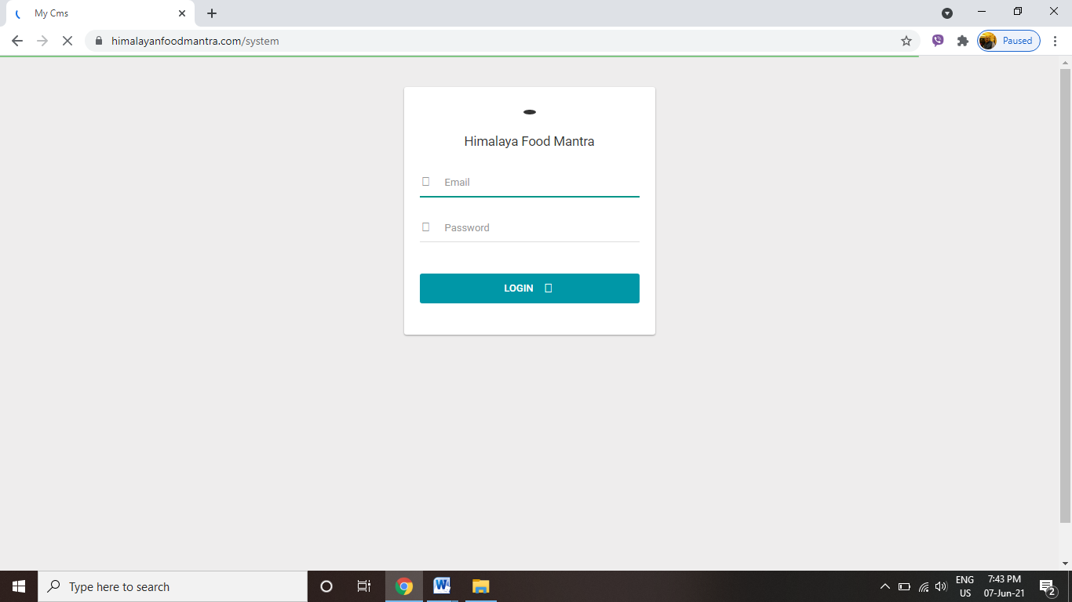

*Screenshot: Admin Login of Himalayan Food Mantra*

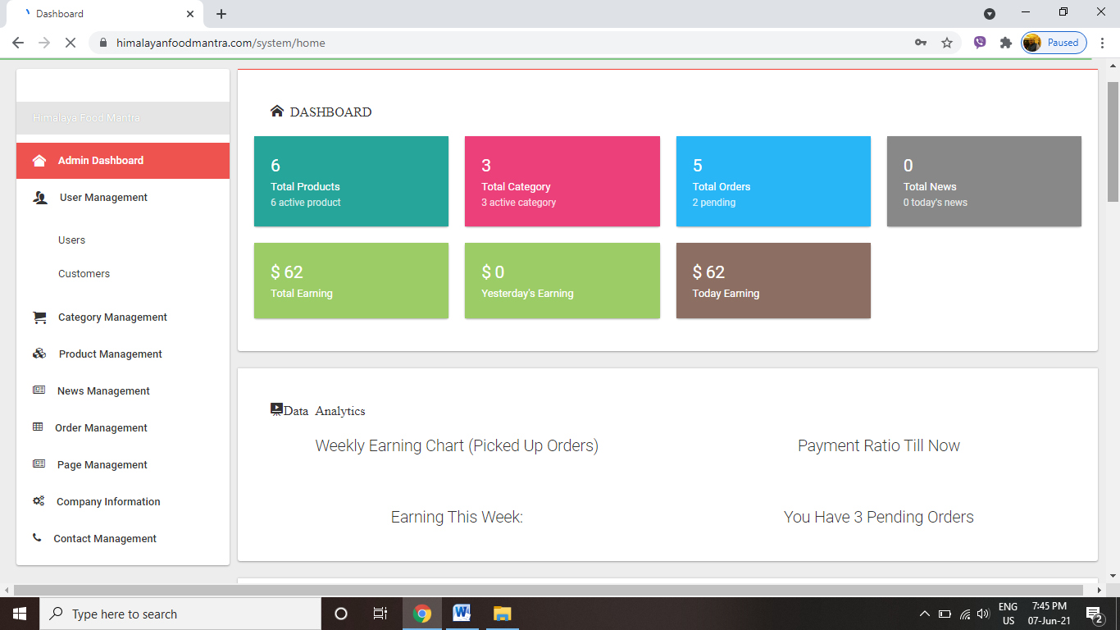

*Screenshot: Admin Dashboard segment 1*

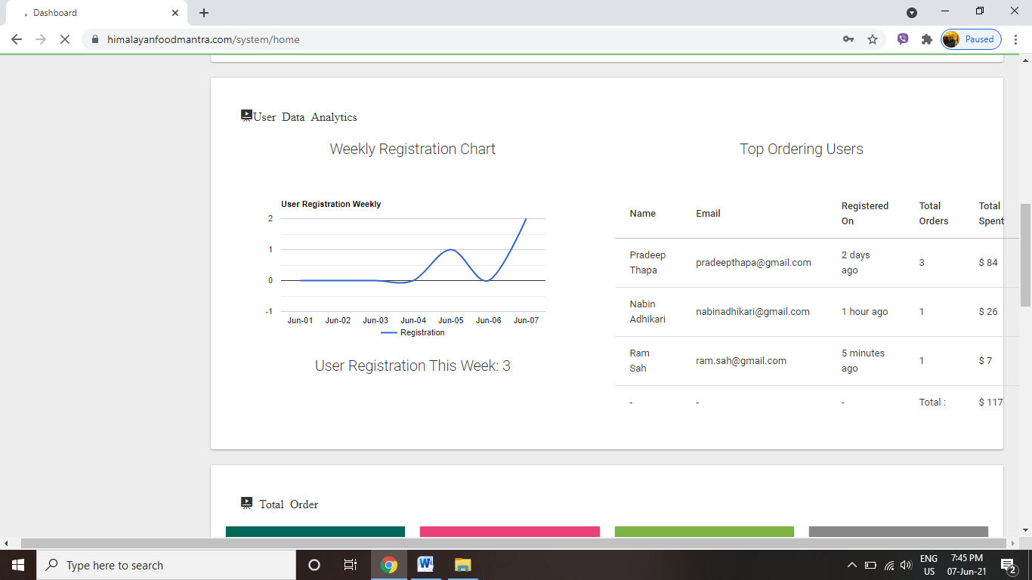

*Screenshot: Admin Dashboard segment 2*

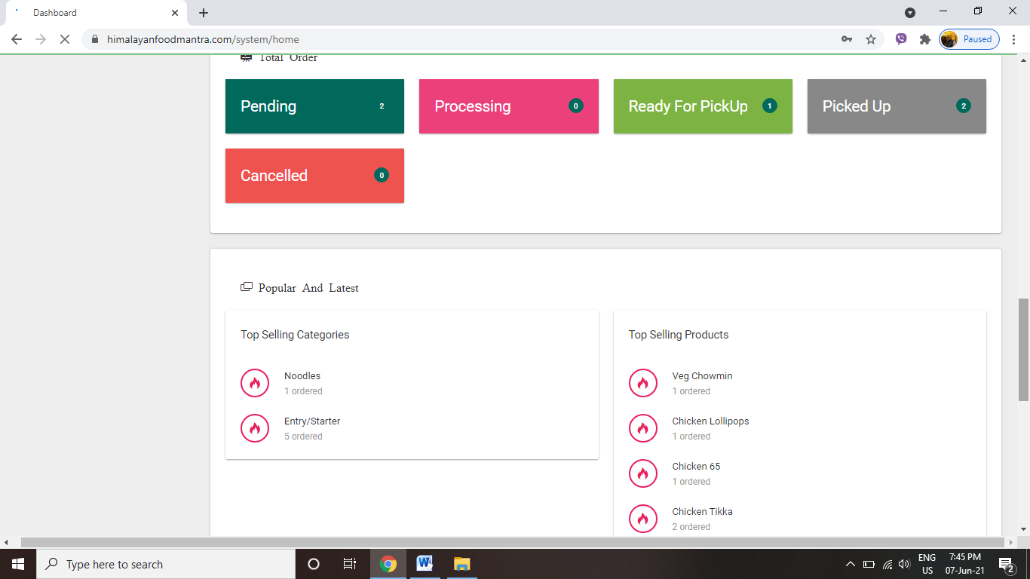

*Screenshot: Admin Dashboard segment 3*

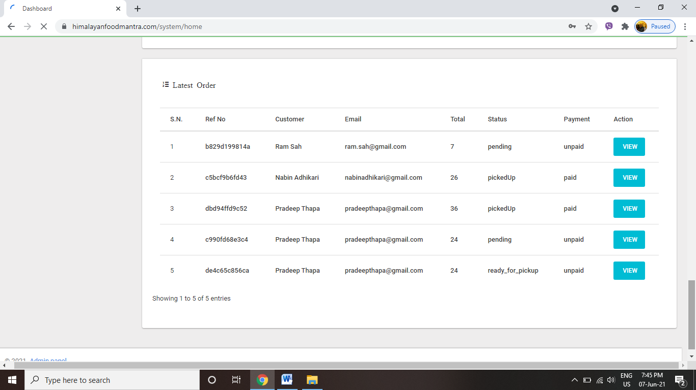

*Screenshot: Admin Dashboard segment 4*

*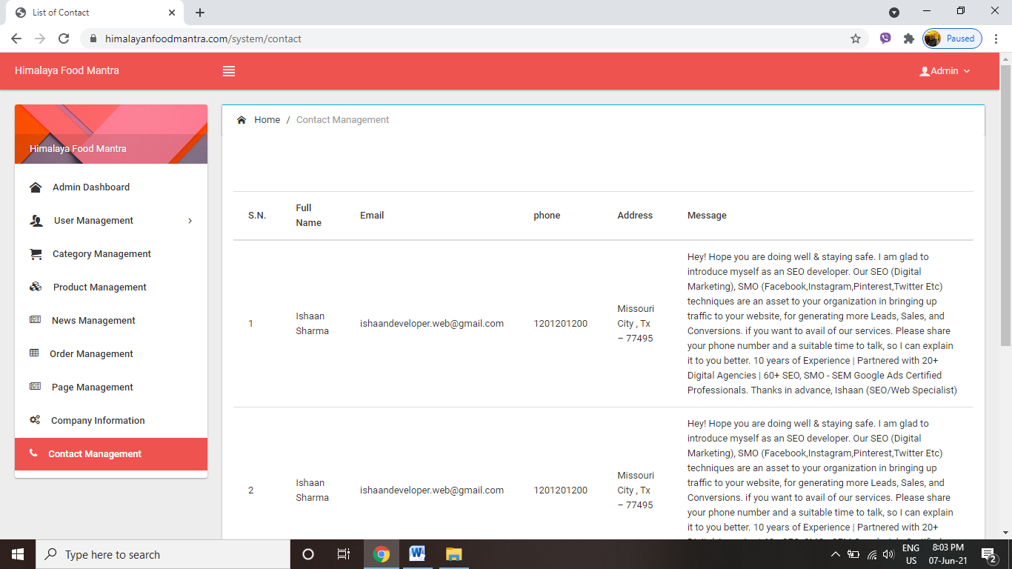  
Screenshot: Contact Management of Himalayan Food Mantra*

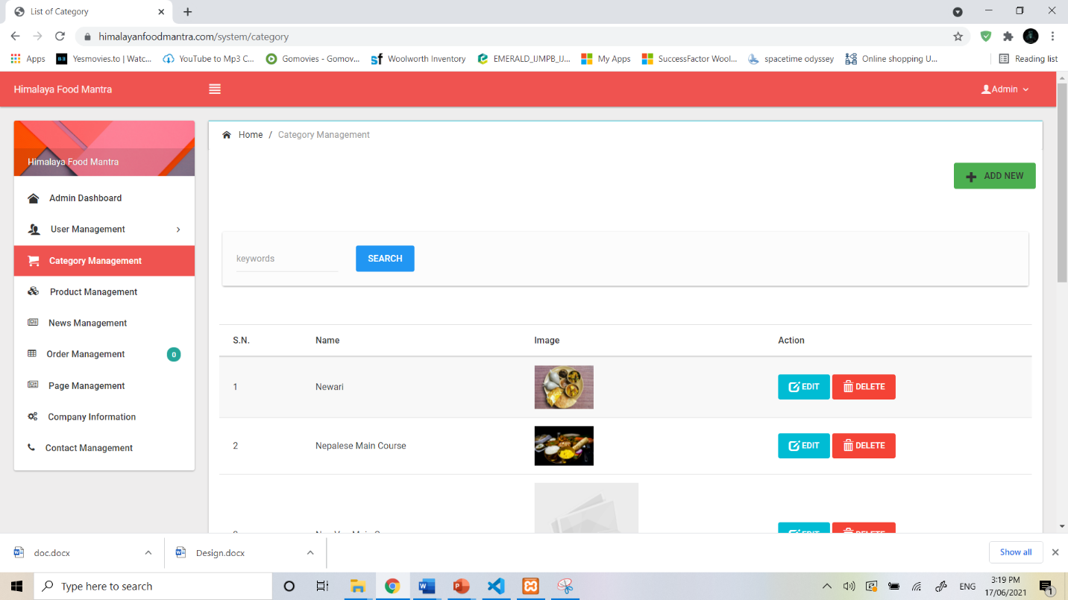

*Screenshot: Category Management of Himalayan Food Mantra*

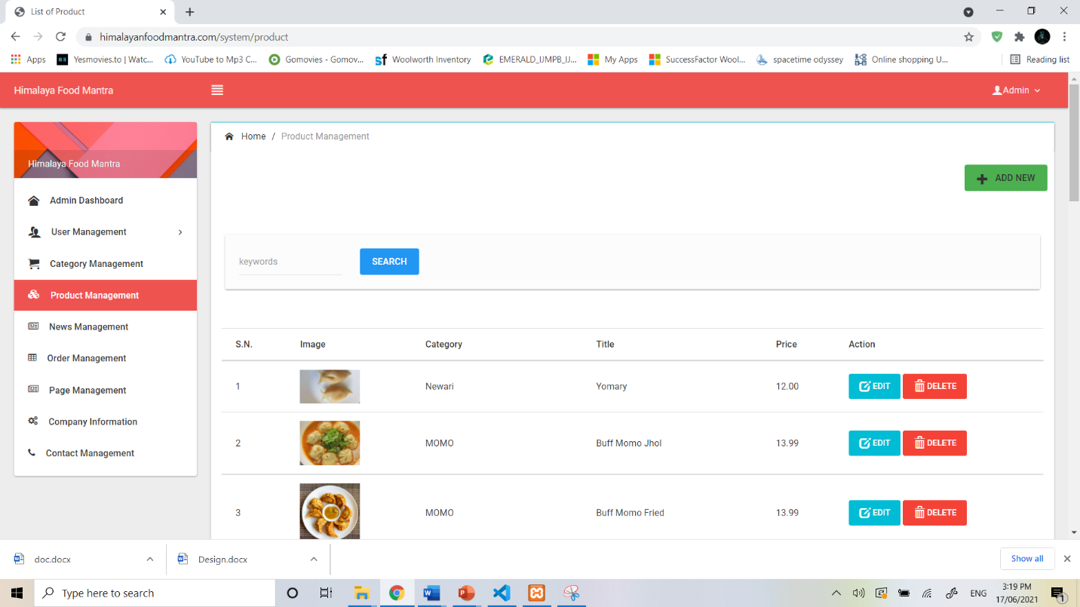

*Screenshot: Product Management of Himalayan Food Mantra*

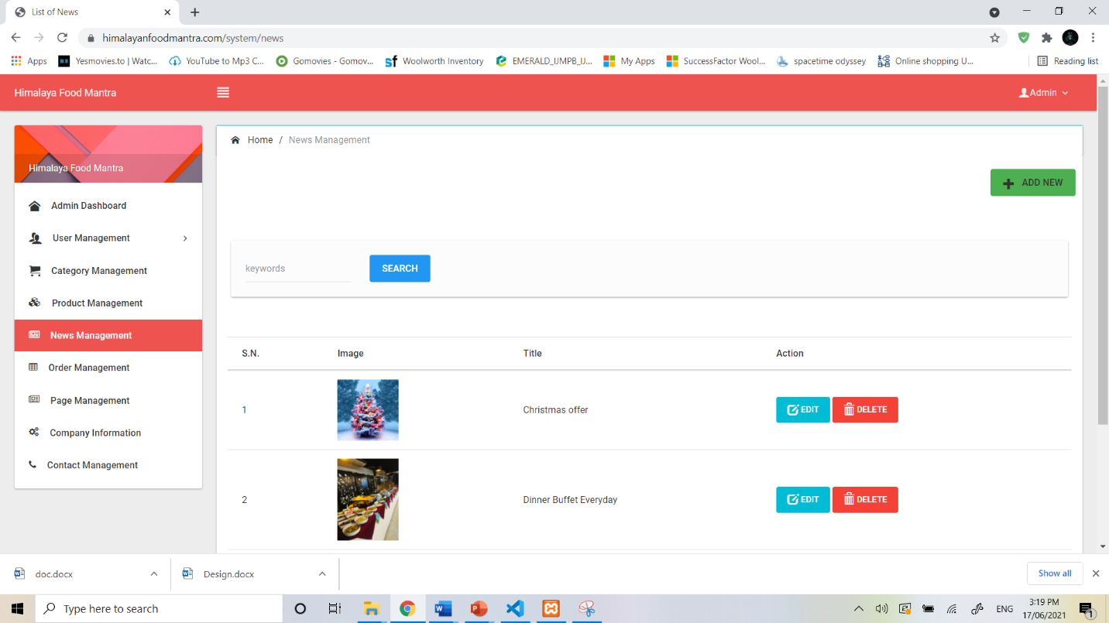

*Screenshot: News Management of Himalayan Food Mantra*

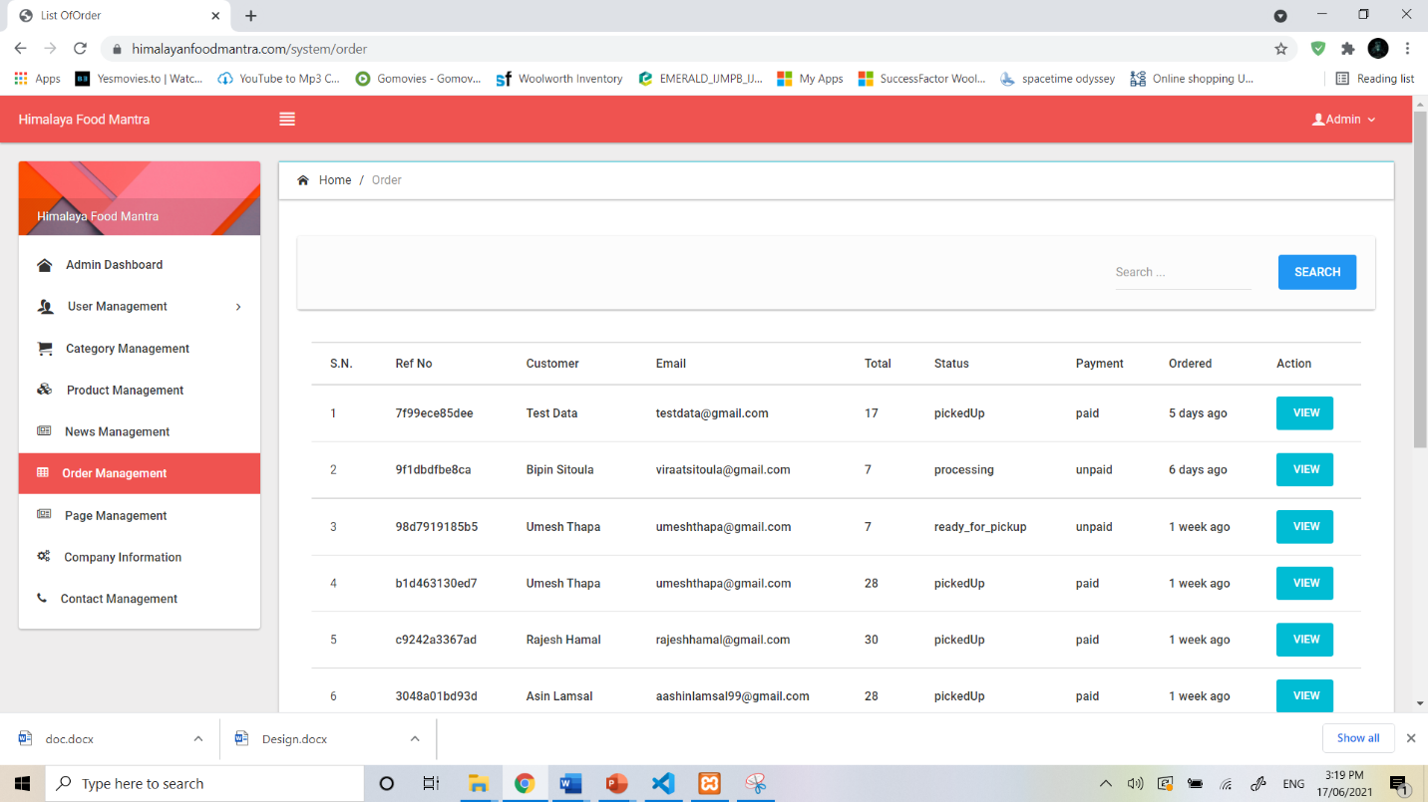

*Screenshot:Order Management of Himalayan Food Mantra*

## 9.3 Business Viewpoint

### 9.3.1 Business Purpose

The system focuses on providing facilitations regarding ordering of the food items from the application together with getting to know more about the recipes and other hospitality options. Alike other businesses, the major focus of this application is to provide maximum satisfaction today customer which smooth execution of system features of providing transaction for recipes and food items together with getting latest updates about the hospitality services. Together with facilitating the customers, the system also supports the administrator to manage various operations to track manage and maintain availability of categories of product with the management of details regarding customers, suppliers, users, news and status of the order. The system has been built with an aim to provide hospitality services with minimum human interaction possible (Bhasin, 2019)*.*

### 9.3.2 Business Resources

In order to build implement and maintain the system several resources are required. Foremost the major factor of production that is required for system development is budget finance that assists in financing the other resources. Development also requires serious hardware equipment like servers, devices and more. For the development of system both technically skilled as well as non-technical manpower is essential. Proper information and environment must be provided to them in order to build a system as per the need (Ough, 2020).

### 9.3.3 Business Overview

#### 9.3.3.1 Business Process Model

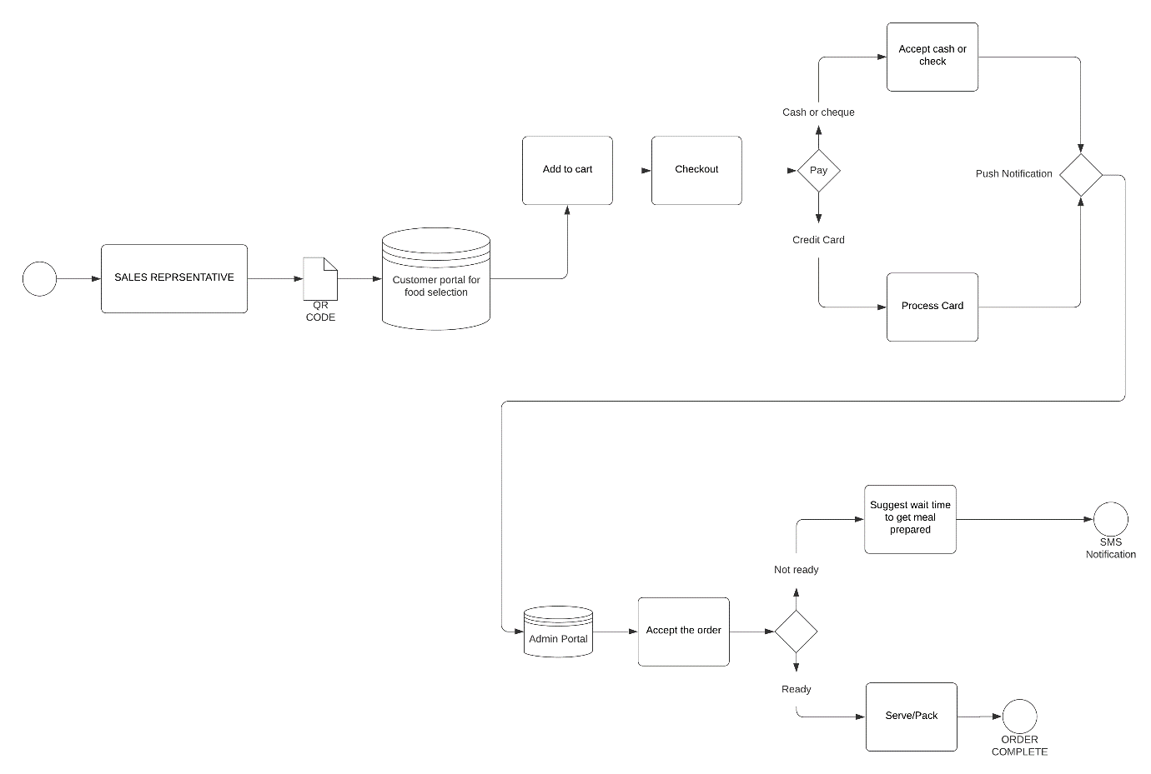The BPMN diagram or business process model and notation diagram, is the representation of and easy to read business flowchart that can be shared among various industries and organization. They are basically four main categories of the group as flow object, connecting object, artifacts and swim lanes. It is one of the best modeling notations that is used for business process as it provides inside to various simple flowcharts of the application. The diagram is more understandable to the non-technicians then the rest of the UML diagrams and can be easily design as well as analyzed (Babcock, 2015). *Figure: BPMN Process Model of Himalayan Food Mantra*

Here the sales representative can view to the customer portal for food selection via are the QR code provided. The database contains all the information regarding categories and products of food items available. After the customer has added it to the card and checked out there are two case scenarios to be checked. While the payment is being done the cash or cheque must be accepted by the representative or if the customer paying the amount via credit card the processing of credit card is done and finally the push notification is then sent to the admin portal. The admin now accepted your order after the payment has been done. There are against to case scenarios to be analyzed. If the product that is ordered is ready to be delivered then the item is either served or packed and the order is finally completed. On the other hand, if the item is not ready yet, a suggestion regarding the expected waiting time for the order to get prepared is send to the customer via SMS notification. In this way the entire process of the business is implemented. This model plays an important role in understanding the major business processes (Anon., 2021).

#### 9.3.3.2 Business State

AS-IS process is used to analyze the current state of the business process. It assists in mapping the processes into the map and solves any issues or gaps travelling in between the modes of operations. Once these processes have been maped, it can now be used to build TO- BE phase of the business process. They are several goals that are targeted while this model is being built such as saving budget, creating new processes or improvising the already existing processes, maximizing customer satisfaction and coordinating various business processes with organizational objective. It also integrates various standards that are regulated by the business (Team, n.d.).

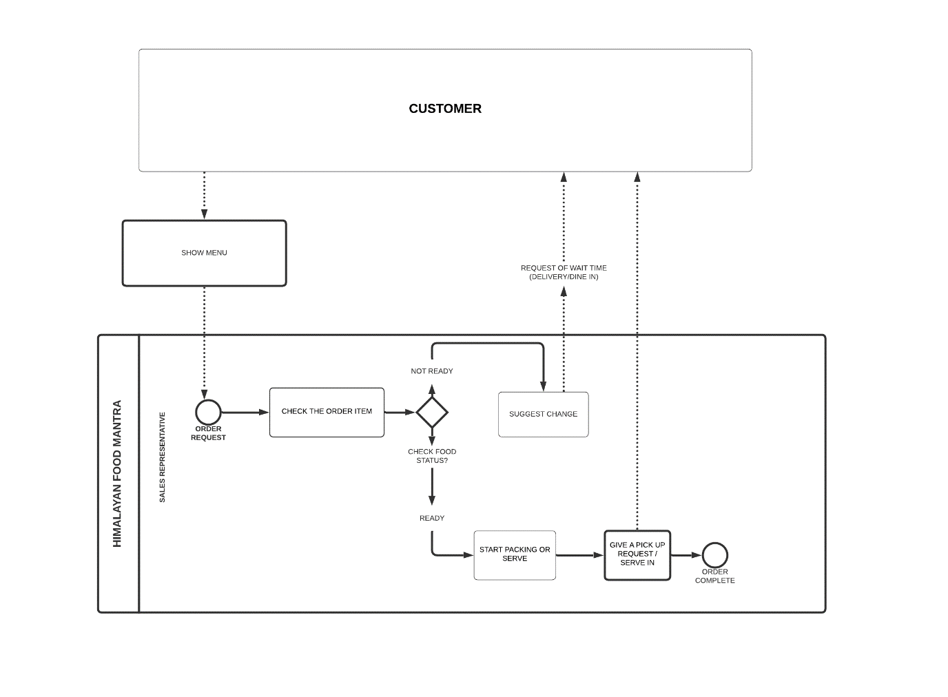*Figure: AS-IS Model of Himalayan Food Mantra*

The diagram given above the customer can view the menu from the Himalayan food Mantra application. The case scenario of after the user has requested for the order has been presented in the diagram. After the order request is received by the application it checks whether or not the item is available or not. It goes through decision making. If the service is not ready then the system responds with message. It can be the request for waiting time for the delivery or dine in to the customer. And if the service is available then packing or serving of the service starts. The message regarding pickup request for service or serve in message is then transferred to the customer. After completion of all the steps, the order is finally complete (Azeem Lodhi, 2010).

### 9.3.3.3 Business Future

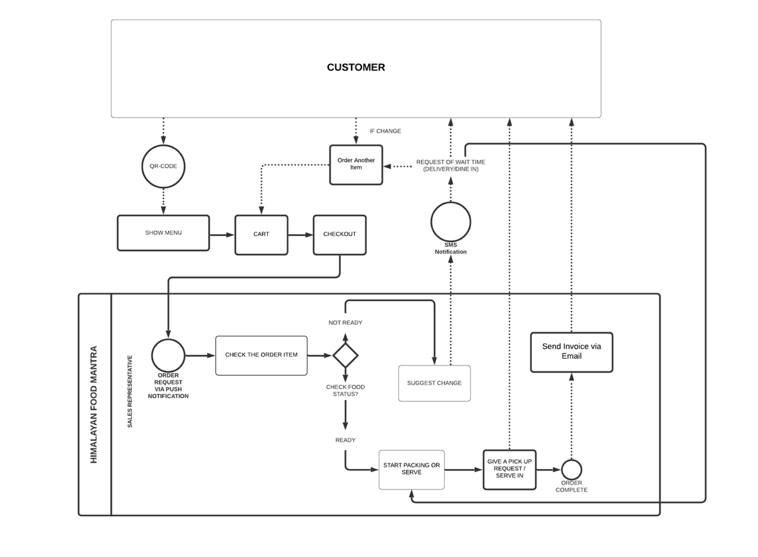The To-Be model of business processes describe about the future state of various processes of the business. It is actually the diagrammatic representation of future goals to be attained by the business. These are the future for cast and strategies that are to be implemented as for the progress in the application takes place. To make the model proper business analysis must be done. With the pictorial presentation of the application, future strategies can be efficiently implemented (Cousins, 2021)

. *Figure: AS-IS Process Model of Himalayan Food Mantra*

In the diagram above, the customer can view the menu of the restaurant using the QR code. As per the liking user can add food items to the cart for checkout. While the user requests for checkout into the system a push notification is sent. The system then checks whether or not the order item is ready. If it is ready then the further packing or serving of the food product is done. The request for pick-up or serve in is declared. This request can be directly forwarded to the customer. After completion of all the orders the process is finally completed. Regarding the completion of the order and invoice or email can be sent to the customer. On the other hand, if the ordered item is not ready yet the system can direct the user on to the suggest change page. This will provide the user with a SMS notification regarding expected time the user has to wait for getting the order ready. If the customer decides to change their order, then they can directly change it and add it to the card and the process will be carried out as it is. If the changed item is available then direct packing or serving can also be initiated. With these features the business targets to grow in the future (Kopp, 2020).

# Testing/Evaluation

We performed user acceptance testing continuously while developing our web application. We also continuously performed unit testing and feature testing of our web application using PHPUnit framework. This framework allowed us to test our code both for unit testing and feature testing. System testing has been done using **acceptance testing** by creating the test cases as below.

## 7.1 Test Cases

|  |  |  |  |
| --- | --- | --- | --- |
| **Test Scenario ID** | 1 | **Test Case ID** | Login -1A |
| **Test case Description** | Registration- valid data | **Test priority** | High |
| **Pre-Requisite** | Valid data | **Post-requisite** | Login |

|  |  |  |  |  |
| --- | --- | --- | --- | --- |
| **S. N** | **Action** | **Input Data** | **Expected Outcomes** | **Remarks** |
| **1** | Open the website | <https://www.himalayan>  foodmantra.com/ | Himalayanfoodmantra home page | Pass |
| **2** | Click on user botton and click on register for free option and fill the form with valid data | Firstname: Test  Last name: Data  Phone no: 0297873953  Email: [testdata@gmail.com](mailto:testdata@gmail.com)  Password: testdata123 | Register successfully & display registration success message | Pass |

|  |  |  |  |
| --- | --- | --- | --- |
| **Test Scenario ID** | 2 | **Test Case ID** | Login -2A |
| **Test case Description** | Registration- invalid data | **Test priority** | High |
| **Pre-Requisite** | Invalid email data | **Post-requisite** | NA |

|  |  |  |  |  |
| --- | --- | --- | --- | --- |
| **S. N** | **Action** | **Input Data** | **Expected Outcomes** | **Remarks** |
| **1** | Open the website | <https://www.himalayan>  foodmantra.com/ | Himalayanfoodmantra home page | Pass |
| **2** | Click on user botton and click on register for free option and fill the form with valid data | Firstname: Test  Last name: Data  Phone no: 0297873953  Email: [testdatagmail.com](mailto:testdata@gmail.com)  Password: testdata123 | Should not register and show pop-up message  “Please enter an email address” | Pass |

|  |  |  |  |
| --- | --- | --- | --- |
| **Test Scenario ID** | 3 | **Test Case ID** | Login -3A |
| **Test case Description** | Login- positive test case | **Test priority** | High |
| **Pre-Requisite** | An authentic user credentials | **Post-requisite** | NA |

|  |  |  |  |  |
| --- | --- | --- | --- | --- |
| S. N | Action | Input data | Expected output | Remarks |
| 1 | Open the website | <https://www.himalayan>  foodmantra.com/ | Himalayanfoodmantra home page | Pass |
| 2 | Click on the user button and enter correct email and password | Email: [testdata@gmail.com](mailto:testdata@gmail.com)  Password: testdata123  *********** | Show the profile details and order details | Pass |

|  |  |  |  |
| --- | --- | --- | --- |
| **Test Scenario ID** | 4 | **Test Case ID** | Login -4A |
| **Test case Description** | Login- negative test case | **Test priority** | High |
| **Pre-Requisite** | Invalid user credentials | **Post-requisite** | NA |

|  |  |  |  |  |
| --- | --- | --- | --- | --- |
| S. N | Action | Input data | Expected output | Remarks |
| 1 | Open the website | <https://www.himalayan>  foodmantra.com/ | Himalayanfoodmantra home page | Pass |
| 2 | Click on the user button and enter correct email and password | Email: [testdata@gmail.com](mailto:testdata@gmail.com)  Password: testdata12  *********** | Incorrect login details | Pass |
| 3 | Click on the user button and enter correct email and password | Email: [testdat@gmail.com](mailto:testdat@gmail.com)  Password: testdata123  *********** | Incorrect login details | Pass |

|  |  |  |  |
| --- | --- | --- | --- |
| **Test Scenario ID** | 5 | **Test Case ID** | Login -5A |
| **Test case Description** | Order food before login | **Test priority** | High |
| **Pre-Requisite** | NA | **Post-requisite** | NA |

|  |  |  |  |  |
| --- | --- | --- | --- | --- |
| **S. N** | **Action** | **Input data** | **Expected output** | **Remarks** |
| 1 | Open the website | <https://www.himalayan>  foodmantra.com/ | Himalayanfoodmantra home page | Pass |
| 2 | Choose a food. | Click on  Buff Momo fried image | Show a picture and add to cart option | Pass |
| 3 | Click on featured product add to cart | Buff Jhol momo | Request for login | Pass |
| 4 | Click on order now option and click on any food menu | click in button.  Thali Veg | Show the page with different food categor.  Show a picture and add to cart option | Pass |
| 5 | Click on add to cart option after any of the action above from 1-4 | Click on add to cart | Request for login | Pass |
| 6 | Login after add to cart click after choosing the food | Email: [testdata@gmail.com](mailto:testdata@gmail.com)  Password: testdata123  *********** | Login and food added into the cart. | Pass |

|  |  |  |  |
| --- | --- | --- | --- |
| **Test Scenario ID** | 6 | **Test Case ID** | Login -6A |
| **Test case Description** | Order food after login | **Test priority** | High |
| **Pre-Requisite** | Login | **Post-requisite** | NA |

|  |  |  |  |  |
| --- | --- | --- | --- | --- |
| S. N | Action | Input Data | Expected Outcomes | Remarks |
| 1 | Open the website and login into the system | <https://www.himalayan>  foodmantra.com/  Email: [testdata@gmail.com](mailto:testdata@gmail.com)  Password: testdata123  *********** | Open the homepage and login into the system | pass |
| 2 | Click on order now button | Click on order now button | Shows the food menus with different category | Pass |
| 3 | Choose any food | Faphar roti set | show add to cart option | Pass |
| 4 | Add to cart | Click on add to cart for Faphar roti set | Product added in the cart | Pass |
| 5 | Check out | Click on checkout option | The payment details page should be displayed | Pass |
| 6 | Enter the check out details. | First Name: Test  Last name: Data  Email: [testdata@gmail.com](mailto:testdata@gmail.com)  Address: 32-66 Fletcher St  Phone No: 0297873954 | No any warning during the form fill | pass |
| 7 | Continue to checkout | Click on continue to check out bottom | Thank you.  Continue shopping | Pass |
| 8 | Continue shopping | Click on continue shopping | Takes back to the menu page | Pass |

|  |  |  |  |
| --- | --- | --- | --- |
| **Test Scenario ID** | 7 | **Test Case ID** | Login -7B |
| **Test case Description** | Admin Login- positive test case | **Test priority** | High |
| **Pre-Requisite** | An authentic user credentials | **Post-requisite** | NA |

|  |  |  |  |  |
| --- | --- | --- | --- | --- |
| S. N | Action | Input data | Expected output | Remarks |
| 1 | Open the website | <https://www.himalayan>  foodmantra.com/system | Shows the login form | Pass |
| 2 | Click on the user button and enter correct email and password | Email: [admin@gmail.com](mailto:admin@gmail.com)  Password: admin  ***** | Takes to the admin dashboard. | Pass |

|  |  |  |  |
| --- | --- | --- | --- |
| **Test Scenario ID** | 8 | **Test Case ID** | Login -8B |
| **Test case Description** | Admin Login- negative test case | **Test priority** | High |
| **Pre-Requisite** | unauthentic user credentials | **Post-requisite** | NA |

|  |  |  |  |  |
| --- | --- | --- | --- | --- |
| S. N | Action | Input data | Expected output | Remarks |
| 1 | Open the website | <https://www.himalayan>  foodmantra.com/system | Admin login form | Pass |
| 2 | Insert invalid admin login credentials | Email: [admin1@gmail.com](mailto:admin1@gmail.com)  Password: admin12@#  *********** | Incorrect login details | Pass |

|  |  |  |  |
| --- | --- | --- | --- |
| **Test Scenario ID** | 9 | **Test Case ID** | Login -9B |
| **Test case Description** | Admin- manage  -user  -product  -category  -News  -Order  -Page | **Test priority** | High |
| **Pre-Requisite** | Login into the system | **Post-requisite** | NA |

|  |  |  |  |  |
| --- | --- | --- | --- | --- |
| S. N | Action | Input data | Expected output | Remarks |
| 1 | After admin login to the system, click on user management | Click on user management option | Show user and customer manage option | Pass |
| 2 | Manage user | Click on user option | Show existing user and their roles with their delete option.  Provide option to add new user | Pass |
| 3 | Add new user- superuser/admin | Click on add new bottom | Show the user details entry form | pass |
| 4 | Add the details of the user-superuser with valid details | First Name: Test  Last Name: Admin  Email: [testadmin@gmail.com](mailto:testadmin@gmail.com)  Password: testadmin123  Confirm password: testadmin123  Roles: superuser  Status: Active | User added and show in the user list. | pass |
| 5 | Add the details of the user-superuser with invalid details | First Name: Test  Last Name: Admin  Email: [testadmingmail.com](mailto:testadmin@gmail.com)  Password: testadmin123  Confirm password: testadmin12  Status: active | Data was not saved and not added in the superuser list | Pass |
| 6 | View the list of customers | Click on customer from user management bottom | Show the list of registered customers | pass |
| 7 | View category | Click on category management bottom | Show the list of categories created before | Pass |
| 8 | Add category | Click on add new bottom after click on user management option | Show the category form | Pass |
| 9 | Add the category details | Name: Newari  Image: newarifood.jpg | Successfully added.  And list the new category and display in the customer side. | Pass |
| 10 | View existing product | Click on product management bottom | Show the list of products added. | pass |
| 11 | Add new product | Click on add new product bottom after clicking on product management option | Show the product add form. |  |
| 12 | Add product details | Category: Newari  Title: Yummary  Slug: Yummary khuwa  Product ingredients:  Rice floor, khuwa (milk cream).  Short Description: The traditional food of Kathmandu Valley the capital of Nepal. This food belongs to the indigenous Newar community of kathmandu valley.  Description: -  Price: 12$  Image: Yomary.jpg | Successfully added and is displayed in the customer side. | Pass |
| 13 | Add news | Click on news management option | Show the previous news and add new news option redirecting to another page | Pass |
| 14 | Delete/Edit News | Click on news management option and click on delete bottom if you want to delete and click on edit button if you want to edit news. If you click on edit option new edit page appear. Update the news and save. | If you deleted the news. Deletion is successful.  If you update the news updated successfully. | Pass |
| 15 | Add News | Click on add news button after clicking on news management option. | Provide add news form. | pass |
| 16 | Adding news into the form | Title: Christmas offer  Slug: Christmas offer 2021  Description: On the occasion of Christmas of 2021, Himalayan food mantra is providing huge discount on all the food menu. Hurry up and order your food as soon as possible. This is valid for Christmas week only.  Image: Christmas.jpg | Successfully added and should displayed in the customer side. | Pass |
| 17 | Manager order | Click on order management option and check the order details. click on view button to update the order status.  Order from [testdata@gmail.com](mailto:testdata@gmail.com) . Change the status of order to picked up. | Order should be listed with status, total amount, email id.  After the order status is change into picked up the status in the list should change to picked up. | Pass |

## 7.2 Testing Outcomes

The table present above shows various functionality test that had been done during the project development. Based on the scenarios various tests were done and the outcomes generated were analyzed. This test helps to analyze various loopholes that exist in the system and helps to find possible solutions to cover them up. It assures high value of system development. This helps in further reducing of maintenance cost and providing of better usability to the end users together with enhancing the overall functionalities. The system requires continuous monitoring throughout development and maintenance of the system. Also, the system lacks security for which different protocols must be implemented together with various hardware as well as software security features such as firewalls.

# Limitations

There are few limitations towards which the system has yet to work. They are as follows:

* The application could have supported the multi-language functionality as not every global user is comfortable with the use of English language.
* The application stores its information regarding client, and other payment records in cloud which cannot be trusted to be fully secured in case of any accident or cyber-attacks.
* The real time status of the order cannot be provided to the customers.
* Credit card payment system is still left unimplemented.
* Tracking of the delivery can be done using GPS tracking system on delivery vehicle.
* The web application could not provide the mechanism of printing the dockets after receiving the order.

By ensuring that all these limitations are well understood, and all the prevailing risks are mitigated for the overall well-functioning of the web application so that it proves productive for both customer as well as admin and hotel staffs.

# Recommendations

There are always rooms for further development. Some of the recommendations for the application are as follows:

* Business should always look forward to further improvements with together aligned with the customer’s feedback and need of the hour.
* Continuous tracking of the order status is an attractive feature for the customer.
* Security Protocols can be implemented to make the details regarding the restaurant and customer details much secured. This can be done by the integration of Firewall.
* Continuous monitoring and testing of feasibility is must for growth of the application as well as the business.
* Servers needs to be updated as the data and traffic grows.
* Optimize the web app on the search engine.
* Table reservation system can be added to the web application.
* Develop a mobile app so that the IT operations and facilities can be used at maximum. Doing so can allow customers to know the status of their order in real time.
* Online payment system should be implemented soon.

# Conclusion

With the implementation of such an efficient web application in the business processes, companies can take a huge leap towards their successful future. The web application for Himalayan Food Mantra has been designed to serve all- round purposes of the hospitality business company in serving to the needs of the customers and establishing optimum satisfaction.

From the perspective of the end- users, web applications are a reliable source of services via online means. Such remarkable means of direct communication between the provider of service and the users of service are able secure the growth of the business and establish its position in the market. With applications such as this, digital platforms can serve as a of direct communication between the potential customers and business organizations which makes it easier to keep in track expectations of the customers and make fair implementation of the constructive feedbacks and ensure the optimum development of the business process.

The web application has been designed in such a way that it provides a user- friendly method of services and ensures a personalized experience of customers in viewing the menus, ordering food items, booking and reserving halls and catering services.

Digitalization of business processes are integral to their success today, and a web application designed to serve the smooth flow of businesses and communications between the provider and users can surely do wonders in the success of a business. the web application development process went through a series of processes including establishing a proper design plan, working with clients and understanding their all-round expectations, making optimum use of skills and resources in bringing about an efficient web application, evaluation of the results and checking whether the web application is able to fulfill requirements or not. Understanding the web applications reviews from the end users has been an essential part of this project. While developing this web application over several issues which we need to tackle within a short range of time. To ensure a high quality of final product, all the constraints including time, cost and scope of the project well-kept in track and analyzed on a regular basis. The web application development process went through continuous monitoring of whether the project plans are being implemented carefully and whether they are able to secure the successful tenure of the business through the application.